

**Technical Bulletin OPP-TB-262923.101**

**Variable Frequency Drives**

**Motor Bearing Failure Mitigation**

**Background**

Throughout the Commonwealth Campus’ various motors are controlled by VFDs and the University is seeing a rapid and high failure rate of the motor bearings. This document is intended to provide the technicians with information on how to diagnose the problem and possible mitigations to prolong the life of the motor bearings.

**Diagnosis**

A VFD is a type of adjustable-speed drive used in electro-mechanical drive systems to control AC motor speed and torque by varying the motor input frequency and voltage. A VFD’s output to a motor is very different to that of an across-the-line starter or a reduced voltage/soft starter. The VFD outputs a Pulse Width Modulated (PWM) signal to the motor. This PWM signal is a DC signal that is switched on and off to act like an AC voltage. PWM drives are inherently associated with high frequency common mode voltages and currents which may cause trouble with motor bearings. When these high frequency voltages find a path to earth through a bearing Electrical Discharge Machining (EDM) typically occurs. Over time this creates a “Fluting” of the bearings race. Figure 1.1 shows the common path for the high frequency voltages to earth.

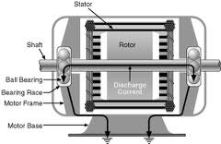

**Figure 1.1**

The main diagnosis of motor bearing failure at the University has been determined to be “Fluting”. “Fluting” or EDM occurs due to sparking between the bearing’s ball and the bearing’s race. Over time EDM-based sparking causes erosion in the bearing race that can be seen as a fluting pattern. In large motors, the stray capacitance of the windings provides paths for high frequency currents that pass through the motor shaft ends, leading to a circulating type of bearing current. Poor grounding of motor stators and rotors can lead to shaft bearing currents. Small motors with poorly grounded driven equipment are susceptible to high frequency bearing currents also. Figure 1.2 shows a typical “Fluted” bearing surface.

Once a bearing has experienced EDM, it will only be a matter of time until the bearing fails. In the early stages of EDM, the bearing will appear normal with no apparent signs of EDM. However, over time the bearing will exhibit bearing noise that will ultimately increase towards the end of its life. Not all bearing failures are due to EDM when controlled by a VFD. Many times bearings fail due to: not being properly greased at the factory, not being re-greased during regular maintenance, or from ultimately reaching the end of their usable life.

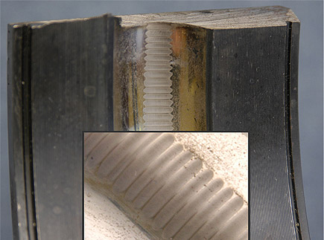

**Figure 1.2**

**Corrective Action**

While there is no one solution to remedy motor bearing “Fluting” there are a few ways to mitigate the risk of “Fluting”.

Remedies:

1. Look for proper grounding of the VFD, VFD cabinet, motor, conduit and driven equipment. See Figure 2.1 for a **PREFERRED** installation diagram of how a system should be grounded when using conduit and shielded cable, Figure 2.1.1 shows a diagram for an **ACCEPTABLE** installation when using conduit only. Proper grounding means a good earth ground, the technician should verify that the installation is connected to a good earth ground before energizing equipment or returning the equipment to service.

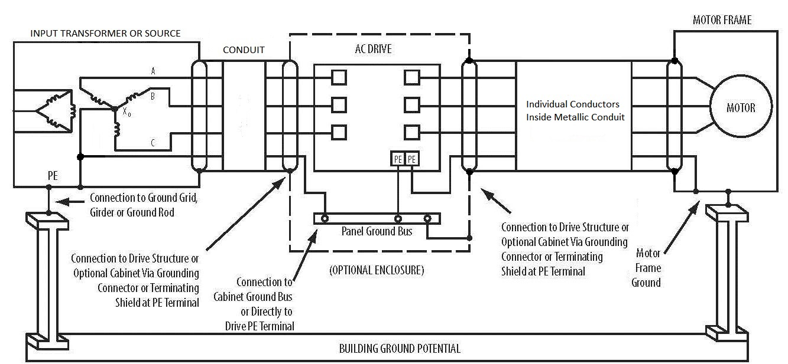

**Figure 2.1**

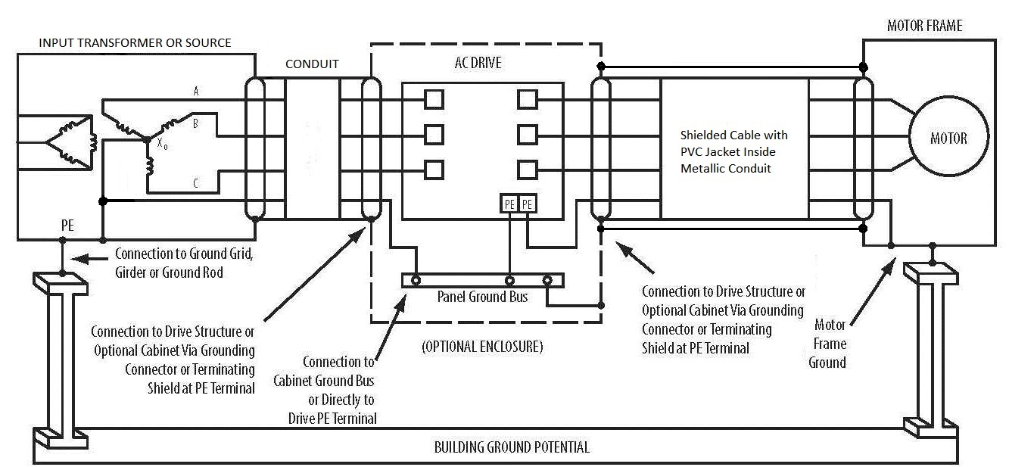

**Figure 2.1.1**

1. Ensure that the conduit has continuous electrical connectivity from the VFD enclosure to the motor connection box. Technicians are to verify that the conduit has continuous electrical conductivity before energizing equipment or returning equipment to service. Technicians are to use the appropriate conduit hubs similar to Figure 2.2. If necessary technicians can helically wrap a green grounding wire, sized appropriately, around the flexible conduit leading up to a motor to ensure conduit conductivity.

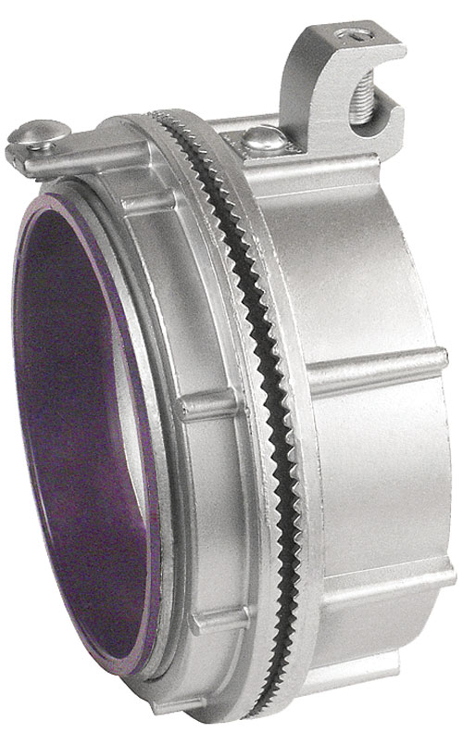

**Figure 2.2**

1. Set the carrier frequency of the VFD to lower than 6 kHz if possible. Authorized qualified personnel shall be the only personnel to change parameters in the VFDs. Contact your supervisor for further assistance.

*NOTE: Setting the carrier frequency to a lower value will increase the noise and or sound coming from the motor. This increase in noise and or sound is NORMAL and does not affect the operation of the motor. The technician will have to use their best judgment when setting the carrier frequency and will have to take into account the surroundings and location of the motor.

1. Verify that a VFD rated shielded cable is installed per the cable manufacture’s recommendation, see Figure 2.3 for a general view of what a VFD might look like. Contact OPP Engineering Services, Electrical Engineers for further information on VFD cable. If a VFD cable is NOT found on a motor that has had bearing failure contact OPP Engineering, Electrical Engineers for further direction.

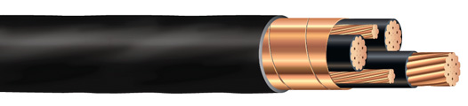

**Figure 2.3**

1. At the direction of Engineering Services install a shaft grounding ring. Follow the manufacturer’s instructions during installation; do not skip any steps during the installation.
2. Ensure that the VFD motor conductors are at least 6” from other power and control conductors.
3. Check that the motor is rated for Inverter or Vector Duty operation. This can sometimes be verified on the motor nameplate or by calling the manufacturer. If a motor is found to not be in compliance, contact OPP Engineering Services. See the list below for a quick check list to verify that a motor is rated for VFD control:
   1. NEMA Design Code: A
   2. Insulation Class H or F
   3. Duty: Continuous
   4. Constant Torque speed range: 10:1, 20:1, 1000:1, 2000:1

*NOTE: The list above may or may not guarantee that the motor in question is rated for VFD use. When in doubt contact the manufacturer for verification, DO NOT assume that the motor is rated for VFD use.

The remedies above can be used as a check list for new installations and renovations to existing systems. However, the most critical items to check are 1, 2 & 3, since they will have the most possible affect on bearing failure.

*NOTE: Although, not an electrical item the Technician should verify that the motor bearings are properly lubricated if applicable. If the Technician is unsure contact your supervisor to alert the proper crew to check the motor bearings lubrication and perform any maintenance.

*Publisher:* Penn State University, Office of Physical Plant, Energy and Engineering Division, Engineering Services

*Editor:* Cyle Vogt, Ph.: (717)-994-7903, email: [cdv5002@psu.edu](mailto:cdv5002@psu.edu)

*Created:* November 1, 2013 *Last Revision:*

*Source Credits:* <http://en.wikipedia.org/wiki/Variable-frequency_drive>; <http://electrical-zine.blogspot.com/>; Allen Bradley Publication: Allen Bradley drives-in001_-en p.pdf; www.southwire.com; www.garvinindustries.com;