

**Technical Bulletin OPP-TB-238216.101**

**Coils (Steam)**

**Condensate Drainage**

**Background**

Steam coils require proper installation of coils and condensate return piping and accessories so that condensate is free to drain completely out of the coil at all times. Full drainage of condensate is necessary to avoid common operating problems ranging from minor to catastrophic failure including:

* reduced heating performance (coil cannot maintain discharge air temperature setpoint)
* control valve hunting (system cycling)
* potential for nuisance freezestat trips
* destructive water hammer (hydraulic shock)
* collecting corrosive elements (carbonic acid) in portions of the coil and piping
* catastrophic freezing and bursting in cold weather causing disruption and expensive damage to equipment and facility

**Diagnosis**

Common causes of inadequate condensate drainage:

1. **Inadequate Coil Pitch:** Positive condensate drainage requires a minimum pitch of 1/8” per foot of coil length toward condensate connection. This may be done either by internally pitched coils within the casing or the whole casing must be pitched externally.
2. **No vacuum breaker on temperature regulated systems:** In most HVAC applications, inlet steam pressure must be significantly reduced to achieve a slight reduction in temperature and heating capacity. When the steam control valve modulates towards being closed, the pressure drops and as steam condenses, the pressure in the coil falls below atmospheric (or any pressure at the discharge of the trap), thus creating a vacuum condition and the condensate will not drain. Thus, a vacuum breaker is required on temperature regulated applications. A vacuum breaker fitted to the steam trap would be incorrect because the hydraulic head of the fill leg would hold the vacuum breaker closed.
3. **Inadequate fill depth between coil outlet and steam trap:** Due to the part load operating conditions described above, supply steam pressure cannot be relied on to operate traps. Adequate pressure is still needed on the inlet of the steam trap to operate. Traps are typically sized for ½ psig differential (1 psig = 2.31’ column of water = 27.7 in. w.g.), so a minimum fill depth of 18” is recommended for condensate to fully drain out of coil and operate trap and to allow for resistance of strainers and fittings. Anything less than 12” means condensate backs up into coil and thus is unacceptable.
4. **Lifts in condensate piping:** Due to the part load operating conditions described above, supply steam pressure cannot be relied on to left condensate after traps. Discharge from the trap must flow by gravity, without any lifts in the piping, to the return system, which must be vented properly to the atmosphere to eliminate any back pressure that could prevent the trap from draining the coil. Where the return main is overhead, the trap discharge should flow by gravity to a vented receiver, from which it is then pumped to the overhead return.
5. **Coil bank assemblies incorrectly piped to a single trap rather than separately:** Two or more coils piped to a common header served by a single trap can cause condensate backup, improper heat transfer, and inadequate temperature control. Therefore individual trap assemblies per coil are necessary. Also, a swing check is needed after each trap if discharging to a common header.
6. **Internally blocked strainers or traps:** Dirt and scale can build up in strainers or in trap orifices and thus restrict or totally block condensate flow. Make sure they are clean and correctly operating.
7. **Inaccessible equipment, strainers or traps:** Mechanical components and piping arrangements that are difficult or impossible to service adequately eventually clog and cause blockages and failures. When discovered, they need to be corrected to the most practical extent.
8. **Inadequate air venting:** Note, this is not a cause of condensate drainage problem, but can contribute to poor performance and coil damage and should be checked as part of overall diagnosis. Air (non-condensable gases) can collect in a coil and reduce its capacity. As steam enters a coil it drives air ahead of it to a drain point, or to a remote area furthest from the input. Depending on the header and tube configuration, particularly with supply connections not at the top, it can be difficult to ensure air is pushed out of the upper tubes and the steam tends to short circuit past these upper tubes to the condensate header. Also, air can diffuse into the condensate forming byproducts, which can lead to severe corrosion. Therefore, it is necessary to provide an automatic thermostatic air vent at the most likely part where air will tend to collect. On coils that have tubes above the steam inlet connection, the vent needs to be installed at the highest point, typically at the top of the condensate header. If air can be effectively pushed to the natural condensate drain point, then the trap must have superior air venting capability and a F&T trap is the first choice. When an inverted bucket trap or other type with limited air venting capacity is used, an auxiliary automatic air vent should be piped in parallel above the trap.

**Corrective Action**

Refer to Figure 1 below for typical schematic of condensate piping and specialties for ensuring condensate drainage and proper operation of temperature regulated applications.

Where any condition or combination of the above are encountered, document the conditions that cannot be initially corrected (location, coil application (preheat or reheat, return air recirculated or 100% OA), equipment identification, nameplate information, pictures, measurements, existing constraints, etc.) bring it to the attention of the Area Supervisor and BOE to develop corrective action plan. Typically that will result in starting a work order - either corrective or emergency depending on severity and time of year with respect to risk for freezing.

If unsure about any portion of the installation, contact a steam and condensate specialties expert for detailed assistance. Failure to properly install any of the components can result in irreparable damage to the coil and/or other components.

Note, be careful not to implement partial fixes. For instance, trying to install a vacuum breaker without correcting condensate piping sections that are above the level of the vacuum breaker or coil drain connection will not correct the drainage problem.

Make sure regular preventive maintenance is coordinated, scheduled and performed. PM shall include the draining and flushing of the condensate drip legs and sediment traps as well as inspection of strainers, condensate traps, vacuum breakers, air vents and valves.

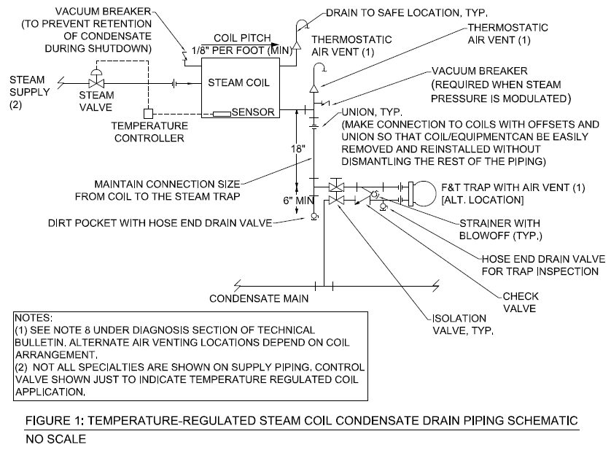

Air vents should be piped to a drain or other suitable location where discharged steam or condensate cannot lead to personal injury or damage to facility. Vacuum breakers should normally not have any discharge and would need to be replaced if discharging any steam, condensate or air.

If piping rework is required, make piping connections to coils and equipment with offsets and short removable sections of piping provided with screwed or flanged unions so arranged that the equipment can be serviced or removed without dismantling the remainder of the piping. Do not screw unions directly in line with coil or tube header piping connections.

*Publisher:* Penn State University, Office of Physical Plant, Energy and Engineering Division, Engineering Services

*Editor:* Scott Rhoads, Building Operations Engineer, Ph: (814) 865-1287, email: [swr101@psu.edu](mailto:swr101@psu.edu)

*Last Revision:* June 18, 2013