

**OPP-TB-238216.010**

[Category]

**Thermostatic Radiator Valve**

**Background**

A thermostatic radiator valve (TRV) is a self-regulating valve fitted to hot water or steam heating system radiators, to control the temperature of a room by changing the flow of fluid to the radiator.

The classic TRV contains a plug, typically made of wax, which expands or contracts with the surrounding temperature. This plug is connected to a pin and in turn connected to a valve. The valve gradually closes as the temperature of the surrounding area increases, limiting the amount of fluid entering the radiator. This allows a maximum temperature to be set for each room.

When a room drops below a specified temperature, a wax plug expands or contracts, controlling a pin connected to a valve. When the valve is triggered, it will open to allow warm fluid to flow into the radiator. When the room has reached the desired temperature, the valve will gradually close.   
  
Valves gauge the temperature of a room using the air directly around them so it’s imperative to ensure that they are not covered by curtains or any other material. They need an uninhibited passage of air flow to allow them to effectively read the temperature of the room.

**Diagnosis**

Perform visual inspection of the thermostatic radiator valve and sensor element and perform corrective measures if any of the following conditions are discovered:

1. Occupants complain of lack of heat.
2. Sensing element located above and/or too close to the heating source.

The following image is showing an incorrect installation. In this position, heat from the steam piping satisfies the controller and prematurely closes the valve. (Notice how the occupant has adjusted the valve to the maximum setting of “5” in an effort to compensate.) The thermostatic valve operator should be mounted horizontally or be equipped with a remote sensor bulb.

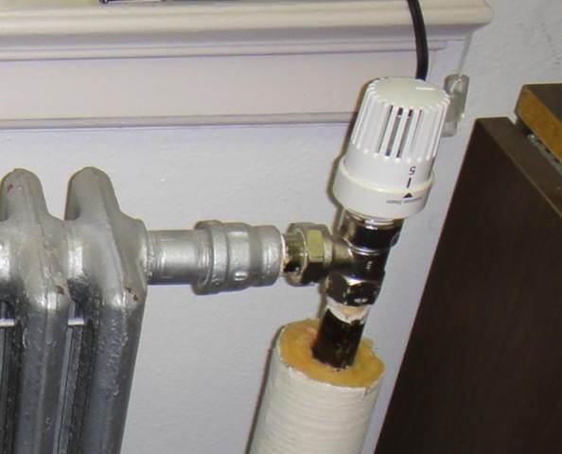

**Corrective Action**

Replace operator and sensing element with a new configuration that allows temperature sensing away from the heat source.

The following image is showing the correct installation of a combination controller/sensor/valve (self-contained thermostatic radiator valve)

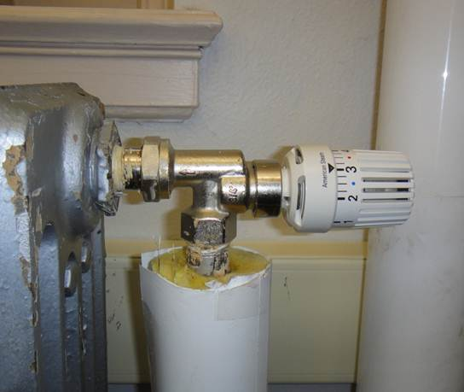

Confirm specific requirements with manufacturer instructions.

*Publisher:* Penn State University, Office of Physical Plant, Energy and Engineering Division, Engineering Services

*Editor:* Vanessa Bierly, Systems Engineering Specialist, Ph: (814) 865-4343, email: [vrb113@psu.edu](mailto:vrb113@psu.edu)

*Last Revision:* May 2, 2013