

**Technical Bulletin OPP-TB-232216.101**

**Steam & Condensate Specialties**

**Y-Type Strainer Orientation**

**Background**

Strainers are used to protect equipment and processes from harmful effects of debris such as scale, rust, joint compound, weld metal and other solids that may occur in the pipeline system. Thus, a strainer is typically installed upstream of steam traps, flowmeters, control valves, and/or heat transfer / process equipment. The correct orientation of the strainer pocket is important and depends on whether the strainer is in a steam or condensate application.

**Diagnosis**

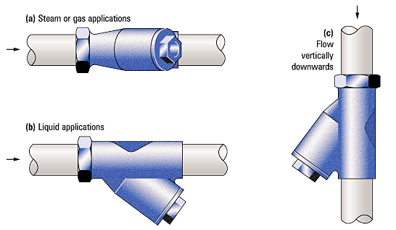

In **horizontal steam** pipes, the strainer pocket shall be in the **horizontal** plane. This prevents water collecting in the pocket, in order to avoid risk of serious equipment damage and safety hazard from water hammer and related stresses and to prevent any water droplets being carried over, which can cause erosion and affect heat transfer processes.

On **horizontal condensate** (liquid) pipes the pocket shall point **vertically** downwards. This ensures that the removed debris is not drawn back into the upstream pipework during low flow conditions.

Although it is advisable to install strainers in horizontal lines, this is not always possible. They can be installed in vertical pipelines IF the flow is downwards, in which case the debris is naturally directed into the pocket. **Installation is** **prohibited with upward flow**, as the strainer would have to be installed with the opening of the pocket pointing downwards and the debris would fall back down the pipe.

**Corrective Action**

Existing Conditions: Where orientation of pocket is incorrect, remove and reinstall per the above and manufacturer's installation instructions.

New Work: Install per above and manufacturer's installation instructions.

*Publisher:* Penn State University, Office of Physical Plant, Energy and Engineering Division, Engineering Services

*Editor:* Scott Rhoads, Building Operations Engineer, Ph: (814) 865-1287, email: [swr101@psu.edu](mailto:swr101@psu.edu)

*Source Credits:* <http://www.spiraxsarco.com/resources/steam-engineering-tutorials/pipeline-ancillaries/strainers.asp>

*Last Revision:* September 25, 2013