

**Technical Bulletin OPP-TB-232123.200**

**HVAC Pumps**

**Cavitation from Clogged Inlet Strainer**

Office of Physical Plant Engineering Services University Park, PA

**Background**

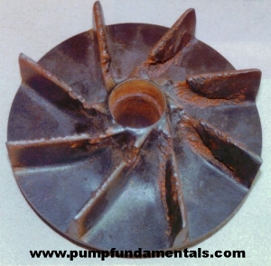Increasing blockages (pressure drops) at pump inlets eventually result in too low of suction pressure, which then leads to cavitation.  Cavitation, which consists of vapor bubbles forming and imploding inside the pump, causes a number of problems. It creates excess noise, increases energy use and cost, and erodes the metal surfaces inside the pump and thus greatly reduces its useful life and leads to high repair or replacement costs. See Figure 1. The objective is first to prevent conditions leading to cavitation, second to get conditions corrected as soon as possible if and when discovered.

**Diagnosis**

Figure 1 - Impeller Eroded from Cavitation

Cavitation sounds similar to rocks or marbles banging around inside the pump. Whenever noticed the pump should be removed from service ASAP to minimize damage and followed up with high priority work order for troubleshooting/repairs.

**Corrective Action**

Initial System Start-Up Operation: Pump inlet strainers/suction diffusers for pumps typically include a temporary fine mesh “start-up screen” initially installed by the manufacturer over the more coarsely perforated final strainer cylinder.     If left in, the too fine mesh screen would tend to result in clogging and building up large pressure drops at pump suction.  **Thus, the fine mesh start-up screen MUST BE REMOVED after initial cleaning/flushing circulation period. See Figure 2.**

Ongoing Operation: **Periodically inspect.** Measure the pressure drop across the inlet strainer/suction diffuser to detect if blockage has built up within the strainer/suction diffuser. Ideally the suction diffuser/inlet strainer should typically include a permanent pressure gauge assembly with adjustable set hand (or improvised marking) to indicate upper limit when service is required. When inspection results indicate need for service, follow the manufacturer’s operation and maintenance instructions to inspect the strainer cylinder and remove any blockages present.

Figure 2 - Typical Suction Diffuser Parts

*Publisher:* Penn State University, Office of Physical Plant, Energy and Engineering Division, Engineering Services

*Editor:* Scott Rhoads, Building Operations Engineer, Ph: (814) 865-1287, email: [swr101@psu.edu](mailto:swr101@psu.edu)

*Document Credits:* Parts for Suction Diffusers, Bell and Gossett, Parts Lists [HS 300F PL Service Parts Catalog Circulators and Centrifugal Pumps](http://documentlibrary.xylemappliedwater.com/wp-content/blogs.dir/22/files/2012/07/HS-300F-PL.pdf)

*Last Revision:* March 18, 2016