

**Technical Bulletin OPP-TB-23 05 19.201**

**Temperature Instruments**

**Heat Conductive Compound**

**Background**

[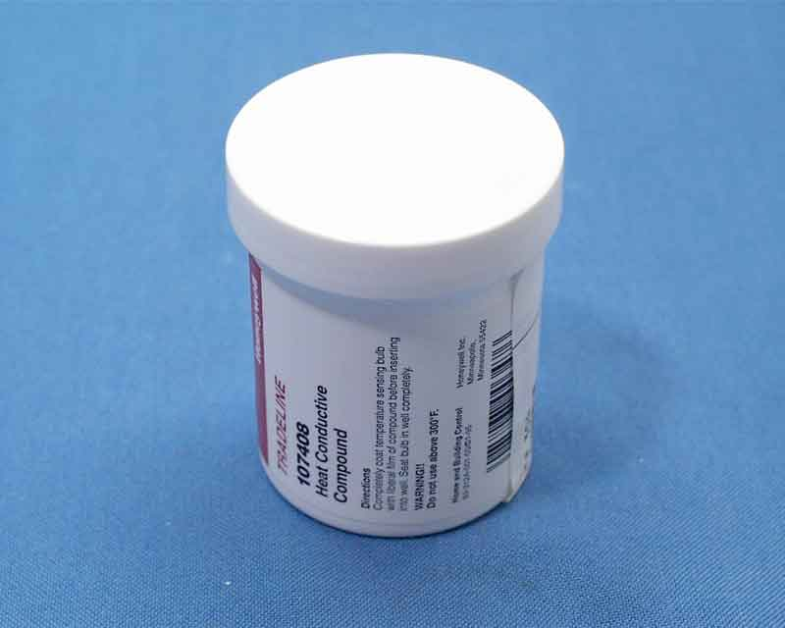](http://146.186.162.193:9080/jsp/images/opp_stores_items/936000.jpg)

Heat conductive compound (also called thermal paste/grease or heat sink paste/grease) is used to improve thermal transfer by filling in air gaps (to increase accuracy and speed of response) and to eliminate condensation and corrosion forming within the thermowell in thermometer and temperature sensor applications. It is also used for surface measurement probes, such as strap-on type sensors.

Compound is available through OPP Stores. Stock Number: [936000](https://apps.opp.psu.edu/opp-stores/item/show?number=936000)

**Diagnosis**

Existing Installations: Check for noticeable temperature differences and/or lagging response time between BAS sensors and thermometers and reliable reference instruments. Remove suspect sensors from thermowell and visually inspect for compound (typically off-white paste). Add if missing, as described in corrective action below.

**Corrective Action**

Follow manufacturer’s installation and safety instructions. Fill voids between thermowell and thermometer and BAS sensor stems with heat conductive compound before installing in wells. Ensure the active length of the sensor is covered. For surface measurement probes, dab a small amount on the surface and push the thermocouple into this area.

Repair/Replacement Applications: Renew compound when sensors are removed and reinstalled to recalibrate, repair or replace malfunctioning items.

Construction Quality Control: Assist in quality control efforts during construction by reminding contractors and OPP QA/QC staff to make sure it is being applied when temperature sensors are installed.

*Publisher:* Penn State University, Office of Physical Plant, Energy and Engineering Division, Engineering Services

*Editor:* Scott Rhoads, Building Operations Engineer, Ph: (814) 865-1287, email: [swr101@psu.edu](mailto:swr101@psu.edu)

*Last Revision:* September 13, 2013