- PURPOSE
The purpose of this procedure is to define what a multi work group (MWG) work order and the work execution, scheduling and documentation processes and procedure to accomplish the MWG work order.

- DEFINITION
A multi work group work order is a planned work order that requires two or more work groups that the work group is led by a different supervisor. A multi work group work order will always have a parent work order and subsequent child work orders with specific target start and target finish dates.

3.0 OBJECTIVE
The objective of this documented process is to maximize multi work group (MWG) work orders wrench time, optimize labor resources, promote seamless work-flow execution, refine schedule coordination, and promote best practices of organizational communication and work execution.

- RESPONSIBLE PARTIES
WORK RECEPTION CENTER (TRIAGING OF THE WORK ORDERS)
PLANNERS
SHUTDOWN COORDINATORS
SCHEDULERS
POINT OF CONTACT (POC)
LEAD TECHNICIANS
TECHNICIANS
WORK GROUP SUPERVISORS
MANAGERS
OPP STORES

- INSTRUCTIONS

Work Reception Center- Reviews the multi work group (MWG) work order in MAXIMO to insure completeness assigns an urgency, reviews location, description, customer billing information and if any required dates are associated with the MWG work order.
Planning – Planners will contact the customer(s)plan the MWG parent work order and all children work orders, order material prior to approving the MWG work orders, and process a shutdown if necessary. The planner on all MWG work order(s) will populate the REQUIRED START/FINISH DATES. Once the work order(s) is planned the planner(s) will notify scheduling to put the work order(s) on the weekly MWG weekly meeting to discuss, at least one (1) month in advance “preferably”, or sooner if necessary.
The planner(s) will inform scheduling of any supervisor, lead technician or technicians that need to interact on this MWG work order will be invited to the meeting.

Shutdown Coordinators – Will contact all necessary staff to get approval for the shutdown

Scheduling- Scheduling will send a meeting announcement to the planner(s) supervisor(s), lead technician(s) or technician(s) that need to interact on this MWG work order all will be invited to the meeting.
Scheduling will ensure the dates populated on all work orders provided by the planner(s) that the required and scheduled start/finish dates work for the work group(s) planned for the job. If the dates are not good, scheduling will provide alternate dates to the planner(s). Scheduling will run the weekly MWG work order(s) meeting.

Point of Contact (POC) will be the employee responsible for ensuring the work follows the planned time line, notifies technicians when to be on the job, and conveys to scheduling if any of the work needs moved forward or backward. If there are any questions by the technicians on the MWG work order they will first go to the POC. The POC could be a lead technician, supervisor, technician.
If the POC has a scheduled day off the supervisor of the POC will be the work group supervisor.

Lead Technician -The lead technician can be the POC for the MWG work order. The lead technician when the POC will coordinate with all other work groups involved in the job. Any questions about the job will be directed toward the lead technician. The lead technician is accountable for ensuring the work groups are at the job at their scheduled time.
The lead technician will communicate and questions with the planner(s) of the job. Once the job is complete the lead technician will ensure all child work orders are closed, the lead technician will then inform their supervisor to close out the parent work order.

Technicians -A technician can be the POC. The technician when the POC will coordinate with all other work groups involved in the job. Any questions about the job will be directed toward the technician. The technician is accountable for ensuring the work groups are at the job at their scheduled time.
The technician will communicate any questions with the planner(s) of the job. Once the job is complete the technician will ensure all child work orders are closed, the lead technician will then inform their supervisor to close out the parent work order

Supervisor- If supervisor is the POC the role of the supervisor is to keep the parent work order open for the entirety of the job. Once the job is completed the supervisor will ensure all child work orders are completed. The supervisor will be accountable for closing the parent work order once the job is completed.
The supervisor can also be selected to be the POC.
The supervisor when the POC will coordinate with all other work groups involved in the MWG work order. Any questions about the job will be directed toward the planner(s). The supervisor is accountable for ensuring the work groups are at the job at their scheduled time.
The supervisor will communicate any questions with the planner(s) of the job. Once the job is complete the supervisor will ensure all child work orders are closed, the supervisor will close out the parent work order and ensure all children work orders are closed.

- COMMUNICATION

Any communication needed between the planner, scheduler, supervisors, lead technicians, technicians dealing with an MWG work order(s) formally using e-mail will now use the communication log of Maximo so all correspondence is tied to this work order.
SEE APENDIX 1.0 to initiate a Communication Log
SEE APPENDIX 1.1 for the Communication Log Screen in Maximo
NOTE: Work Log should continue to be used to document actual work activities

Any communication normally done with Outlook will be done through MAXIMO using the communication log screen

- PARENT AND CHILD WORK ORDERS

- Initiate a Parent Work Order to describe project scope.
The parent work order will document duration for the entire job by populating the required and scheduled start dates and the required and scheduled finish dates.
- Create individual Child Work Orders that define Workgroup resources, materials, and labor needs.
The children work orders for this job will be in date sequence of when the work group(s) needs to be on location to perform their work.
Note: Child Work Order #1 is reserved as the POC job coordinating number. Child Work Order #1 is to be used for the POC to interact with planners, schedulers, and technicians.
- Child work order reference must include the sequence number and the total number of planned work activities i.e. Child 4 of 8
SEE APPENDIX 2.0 FOR DETAILED PARENT AND CHILDREN WORK ORDERS DESCRIPTION

- WEEKLY MEETING
A meeting place hold is in place for OPP 148F for every Wednesday 1:30 to 2:30. If a planner does not notify scheduling that a meeting needs to take place by the preceding Thursday the meeting will be cancelled. The planner will let scheduling know who to invite to the meeting.
At the weekly meeting we will be looking for supervisors to guarantee they will be supplying the required labor on the dates the MWG work order(s) are scheduled for. This new MWG work order(s)process takes priority over all other work with the exception of an already APPROVED SHUTDOWN
APPENDIX 1.0

In the work order go to MORE ACTIONS/CREATE/COMMUNICATION ONCE YOU SELECT COMMUNICATION THE BELOW CREATE COMMUNICATION BOX WILL APPEAR.

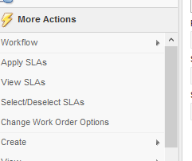
APPENDIX 1.1

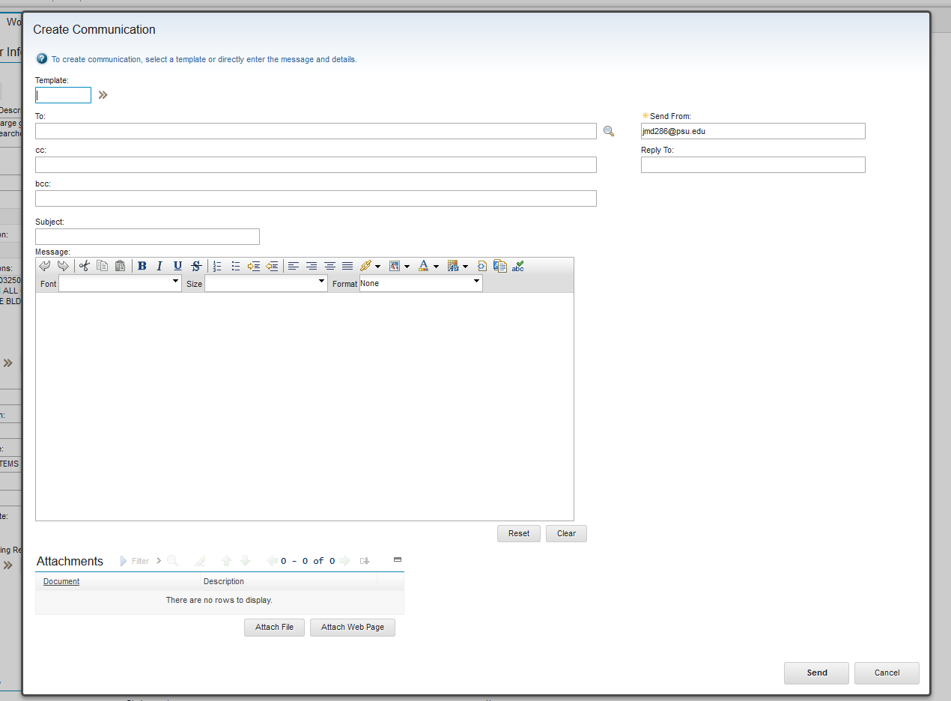

APPENDIX 2.0
The following is the sequence of work orders, the below example is not in exact sequence.

PARENT WORK ORDER AND CHILDREN

PARENT: POC Gene DUBBS 814-323-9876. Planner Heath Lorson 814 327-3345.
Remove existing 150HP pump and replace with a new 3 Phase 150 HP pump. The existing pad is to small and needs removed. A new 4’x6’ pad needs installed. Existing insulation has ACM material. A new pad will need constructed to accommodate the new pump. 7 Child work orders to complete this work.
Note #1: The parent work order will not be closed until the POC verifies all work has been completed. The supervisor of the POC will be responsible for holding the parent open and closing the parent after consulting the POC. The workgroup on the parent work order should be populated to reflect the POC (i.e., Gene Dubbs – MECHMETL).
Note #2: NO LABOR IS TO BE CHARGED DIRECTLY TO THE PARENT WORK ORDER

WORK ORDER. 1 of 7. POC Gene DUBBS 814-323-9876. Planner Heath Lorson 814 327-3345.
– Work type – TS (trouble shooting)
Job Coordinating Number. The purpose of this work order is for the POC to talk with leads and or other technicians to make site visits to the job or answer any questions. This work order will be used to charge time used in discussing the job.

This job coordination work order will now be included on every job with multiple trades

WORK ORDER. 2 of 7 POC Gene DUBBS 814-323-9876.Planner Heath Lorson 814 327-3345.
Asbestos crew to remove ACM from the flange side of the pipe to the first riser for pump #1 ACM is marked to be removed.
Insulation crew to install new covering after new pump is installed and pressure tested.

WORK ORDER. 3 of 7 POC Gene DUBBS 814-323-9876. Planner Heath Lorson 814 327-3345.
Plumbing crew to disconnect all plumbing fittings so the existing pump #1 can be removed. LOTO all valves.
Plumbers to install new pump
Run pump through all necessary steps see attachments for operational check list

WORK ORDER. 4 of 7 POC Gene DUBBS 814-323-9876. Planner Heath Lorson 814 327-3345.
Electrician’s to disconnect existing conductors to pump #1 from the load side of the disconnect. LOTO the disconnect once conductors are removed.
Electricians to install all conduit and conductors for the new pump and check phase rotation

WORK ORDER 5 of 7 POC Gene DUBBS 814-323-9876. Planner Heath Lorson 814 327-3345.
Labor crew to remove existing pump #1 and dispose of. Bring new pump and store in mechanical room adjacent to existing pump.

WORK ORDER 6 of 7 POC Gene DUBBS 814-323-9876. Planner Heath Lorson 814 327-3345.
Cement crew to remove existing pad for pump #1 and replace with a new pad for the new pump. See attachments for specifications.

WORK ORDER 7 of 7 POC Gene DUBBS 814-323-9876. Planner Heath Lorson 814 327-3345.
CCS crew to trouble shoot existing DDC system for proper operation

* If additional material is needed after the MWG work order(s) has been planned, that material will be charged to the child work order that belongs to that work group. An example, if additional electrical material is needed it will be ordered and charged to the electrical child work order. Work order will be used to order any additional material that may be need for the MWG

