- PURPOSE
The purpose of this document is to provide consistent guidance in the effective usage of the BACKLOG status.

2.0 Value of BACKLOG status
- Improve the efficiency and effectiveness of maintenance
- When the flow of incoming work is high, some lower need work must be held back to prevent consuming all the resources too quickly, or in advance of potentially higher priority work appearing.
- When the flow of incoming work is low, having some work in BACKLOG status provides a source of real and known work to accomplish
- It enables the Planner to strategically stage the work order pipeline by:
  - Criticality
  - Labor Resources needed
  - Projected costs
3.0 OBJECTIVE
The objective of this documented process, is to maximize resources, minimize customer impact, and strategically manage work.

- RESPONSIBLE PARTIES
WORK RECEPTION CENTER (TRIAGING OF THE WORK ORDERS)
PLANNERS
SHUTDOWN COORDINATORS
SCHEDULERS
MANAGERS

- PROCESS

- Take ownership of the work order 

- Complete the following on Work Order Tab: 
- Enter Backlog Reason – Select the appropriate backlog value
- Edit Target Start/Finish Dates – Determine the appropriate Target Start and Finish Date
- Add any Attachments that may apply
- Add any Long Description that provide details of the work scope

- Complete the following on Plans Tab: 
  - Labor tab - Enter a labor estimate to include craft and skill
The labor estimate should provide the number of hours required to perform the work.
  - Material tab - Enter the estimated material expenses that sum the projects material costs, and clear Required Date.
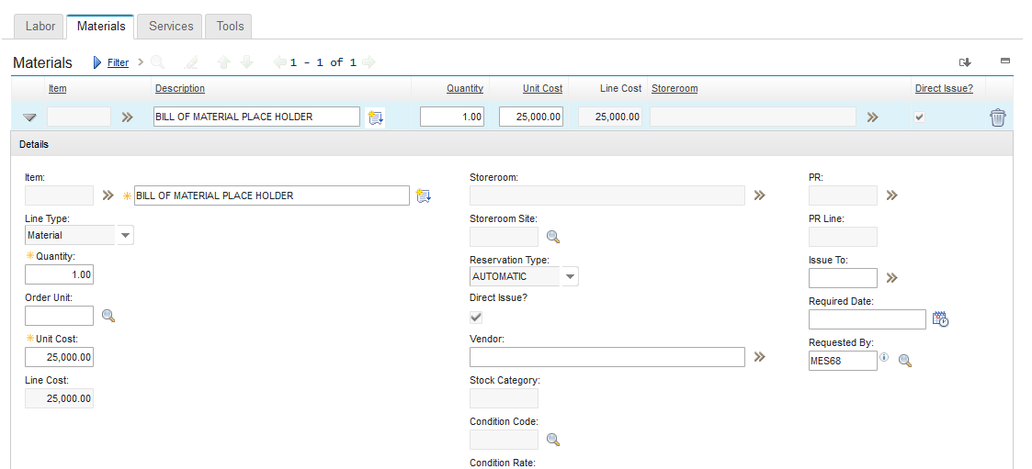
  - Services tab – As needed, enter the estimate expenses associated with outsourcing services, similar to the Material tab process.

- Complete the following on the Log tab 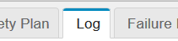
  - Work Log – Offer any added information pertinent to the work order

- Workflow the Work order to BACKLOG status 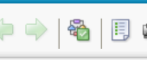
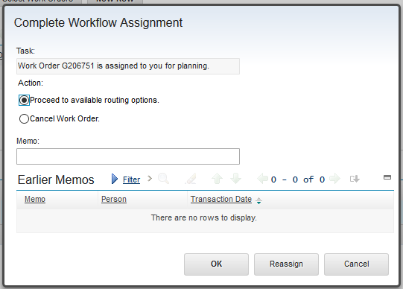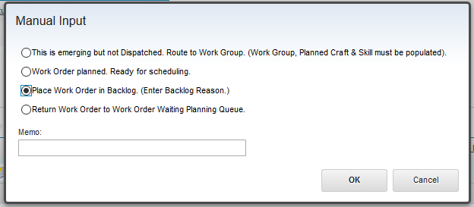
  - Note: If the Backlog Reason is not populated, the status will not be updated

- Update Ownership
  - Either: Keep ownership if planner is waiting on someone for to respond within a reasonable time (less than four weeks)
  - Or: Remove ownership if work is to be planned at a later, more opportune time. To remove ownership, complete the following:
    - Select Owner 
      - From Person Groups tab, select the appropriate
Planner Group, and Route Workflow 