

EZREQUEST USER GUIDE

For Non-OPP Users at PSU-UP



# Document Control

|  |  |
| --- | --- |
| **Title** | EZRequest User Guide |
| **Author** | Melissa Phillips |

|  |  |  |  |  |
| --- | --- | --- | --- | --- |
| **Owner (Responsible for Approval of Issued Versions)** | | | | |
| **Name** | **Role** | **Signature** | **Date** | **Issue** |
| Melissa Phillips | Education Program Associate 2 | Melissa Phillips | 3/29/2020 | 1 |

|  |  |
| --- | --- |
| **Change Log** | |
| **Date** | **Change** |
| 6/26/2020 | SIMBA implementation changes: |
| 10/5/2021 | Removing Web Access screen shot. Adding screen shot of work order details. Updating section on “Who can use EZRequest?” |
| 1/14/2022 | Major editing of the entire document to account for the transition to the use of Service Requests (SR) records for EZRequest entries (SRs effective 1/26/2022). |
| 6/7/2022 | Pages 6 & 8 updated to specify that records in a Canceled or Closed status do not pull in the results. |
| 9/21/2023 | Edited Page 15 to emphasize high degree of detailed specificity in requests and entering the example of events. |
|  |  |

Table of Contents

Document Control 1

What’s New? 3

Benefits of EZRequest? 3

WHO CAN USE EZREQUEST? 4

NAVIGATING TO LOGIN SCREEN: 5

Finding and Signing into the application (app) 5

WELCOME SCREEN 6

FIND 7

VIEW ALL 8

CREATE A NEW WORK REQUEST 11

New Work Request – Searching/Selecting a Location 12

New Work Request – Searching/Selecting a Category 13

New Service Request – Financial Information 14

New Service Request – Description 15

New Service Request – Add Attachments 15

New Service Request – Submission Receipt Confirmation 16

EZREQUEST

### What’s New?

EZRequest was launched in March 2020 and replaced the former work request system, SuiteReq. EZRequest is a simplified, modern webform which allows authorized Penn State employees the ability to submit and track service requests to Penn State’s Office of Physical Plant (OPP) without requiring the use of a Maximo license. The solution was developed in collaboration with OPP’s Enterprise Asset Management team and InterPro Solutions Inc.

Prior to February 2022, when a request was submitted through EZRequest, a work order was initially generated. As of February 10, 2022, requests from EZRequest initially generate as Service Requests in Maximo.

A Service Request (SR) in the simplest terms is a type of ticket. A Work Order (WO) specifies a particular task, a work plan, and the labor, materials and tools needed to complete the work. In Penn State’s OPP University Park Maximo site, a Service Request will not have labor or materials charged to it. SRs and WOs will also be differentiated by different record numbers. At the implementation of SRs, the SR record has a 4-digit identifying number. Work Order records are identified with a leading letter followed by a 6-digit number. SRs can become work orders, or they can remain an SR. A use case for when an SR remains an SR would be a request for Maximo Access or a Maximo feature; these types of SRs remain SRs owned by OPP FAM’s EAM team.

While the SR record also captures financial related data, those fields are not validated against the SIMBA Spending Authorization Table at the creation of the SR. An SR that gets generated to a work order will have the financial information validated during work order triage.  OPP’s Work Reception Center (WRC) will triage the service request entered via EZRequest. OPP’s WRC will create a work order from an EZRequest service request, triage and process the work order according to their existing standard procedure. Please note that requests which are submitted through EZRequest are typically routine. Emergency events or incidents called in to the Work Reception Center will skip the SR process, be entered as work orders in Maximo by the WRC team and processed/dispatched expediently following their existing process and policies.

### Benefits of EZRequest?

* Modern looking, intuitive, easy-to-use webform
* Significant Cost savings to the University as EZRequest Users do not consume a Maximo license
* Instant Search feature

## WHO CAN USE EZREQUEST?

* Authorized Penn State employees identified and approved by their Facility Coordinator (FC) to submit requests to OPP.
* Authorized OPP employees.

Newly hired Penn State employees at University Park (external to OPP) requiring access to EZRequest to submit service requests should contact their Facility Coordinator (FC). To find your Facility Coordinator go to: [https://opp.psu.edu/facilities-coordinators.](https://opp.psu.edu/facilities-coordinators) If an employee is approved to submit service requests on behalf of a specific budget or cost object, the FC will in turn reach out to Georgia Harbst, Facilities Representative with OPP’s Planning, Design and Properties, to coordinate with OPP’s Enterprise Asset Management (EAM) team.

With the implementation of SIMBA in July 2020, EZRequest users will also need to have financial authority for the cost objects they are requesting work/or services on that are not maintenance related. A customer funded request will need to be entered by someone who is listed on the SIMBA Spending Authorization Table for the budgets which they are authorized to incur expenses on. Users would need to work with their Facility Coordinator and Financial Officer to obtain financial authority on the SIMBA Spend Authorization Table.

**Financial Authority is a SIMBA requirement and separate from EZRequest Access/Permissions.**

Unauthorized users attempting to log in to EZRequest will receive the following error:

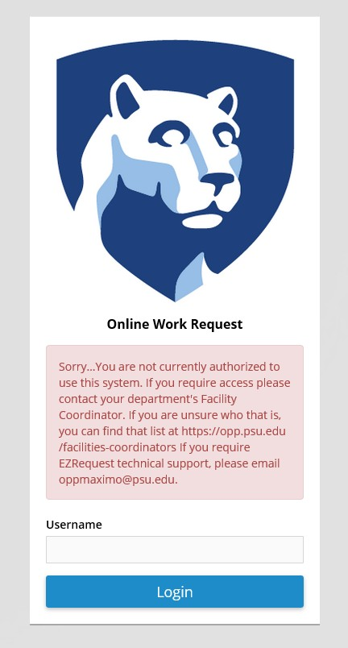

## NAVIGATING TO LOGIN SCREEN:

### Finding and Signing into the application (app)

A link to [EZRequest](https://ezrequest.opp.psu.edu/ezrequest) can be found on the OPP Website, opp.psu.edu, under OPP Quick Links. EZRequest URL: <https://ezrequest.opp.psu.edu/ezrequest>

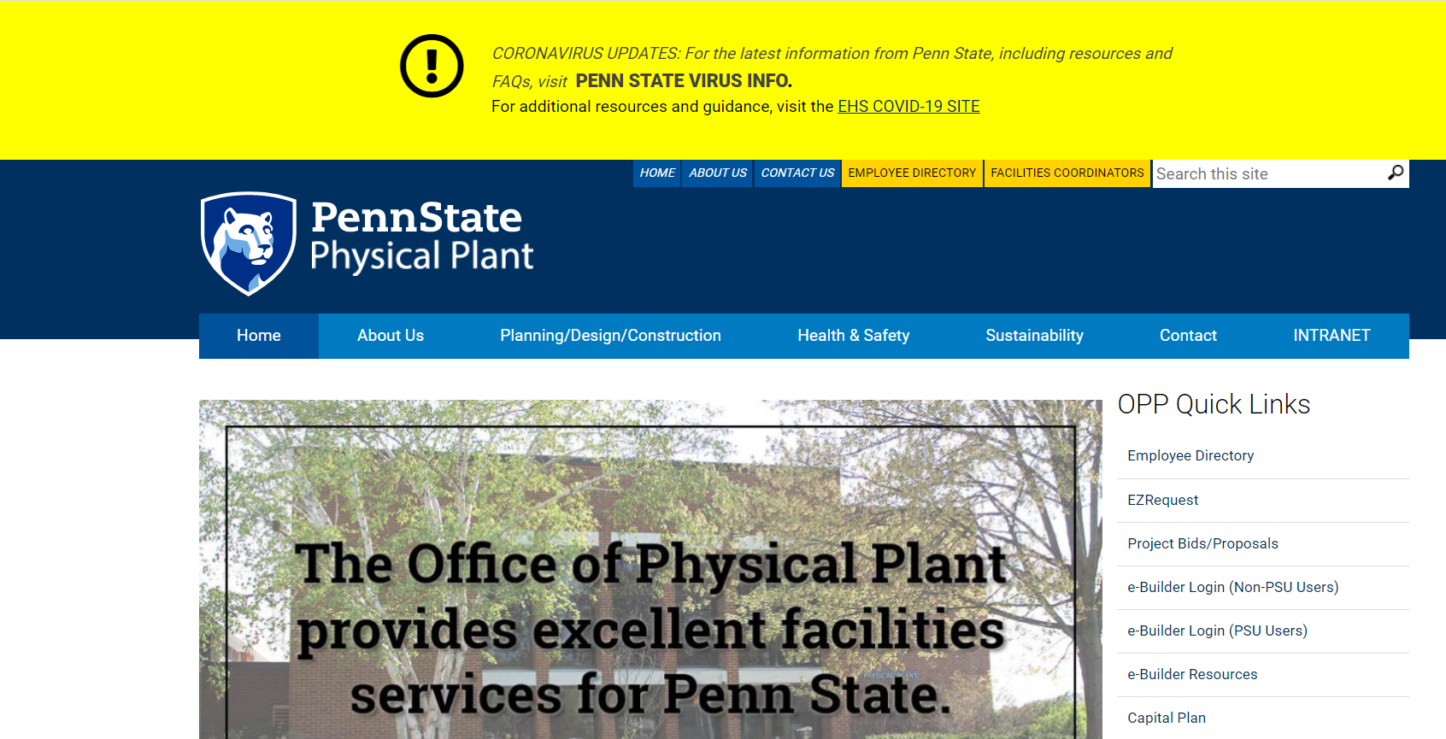EZRequest will require login with your Penn State User credentials.

## WELCOME SCREEN

On the Welcome screen, users can:

* Find - View and search through service requests in any status previously submitted by the signed in user,
* View All- View all service requests and work orders, excluding PMs and records in a Canceled or Closed status,
* Create - Create a new request.

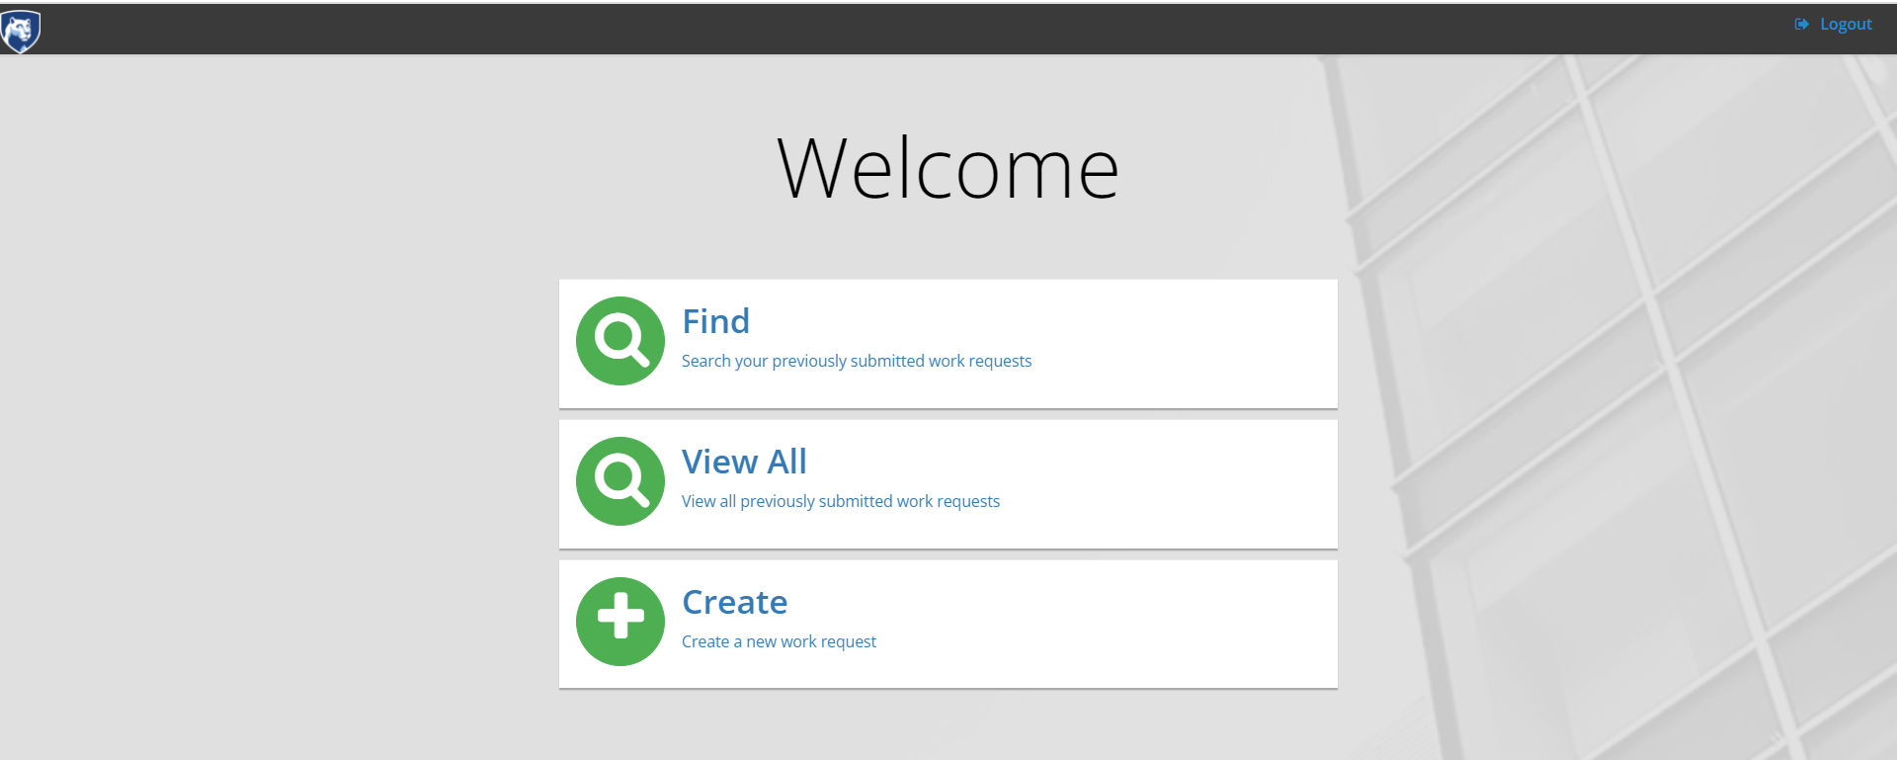

## FIND

The Find tile allows users to view and search all of their own previously submitted requests. As part of the transition to Service Requests, users will see their previously submitted work orders, which were not generated from a Service Request, as well as any Service Request entries in the Find tile results.

Review the navigational features of tiles below.

1. To return the Welcome screen, click on “Home.”
2. To export a list of work requests to Excel or PDF, enter any search parameters as desired and then, click on the respective file type button.

Note: The results you are displaying are the results you will export.

1. On the filter bar, you can instantly search and sort results by Request #, Work Order #, Work Order Description, Location Description, Request Status, Last Status Date and Reported Date.
2. Users can navigate through different pages of records by selecting the page number, previous or next options available at the bottom right of the page.
3. To logout of the system, Select “Logout” in the top right of the screen.

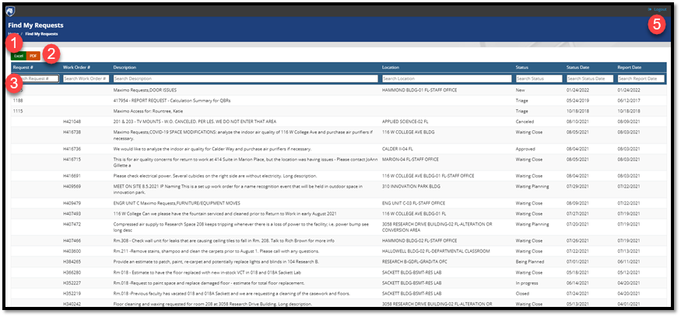

## VIEW ALL

By selecting the **View All** tile, users can search and view all open SRs and Work Orders (with the exception of PMs and records in a Canceled or Closed Status). The **View All** tile is different from the **Find** tile in that viewers can search more than just their own previously submitted service requests.

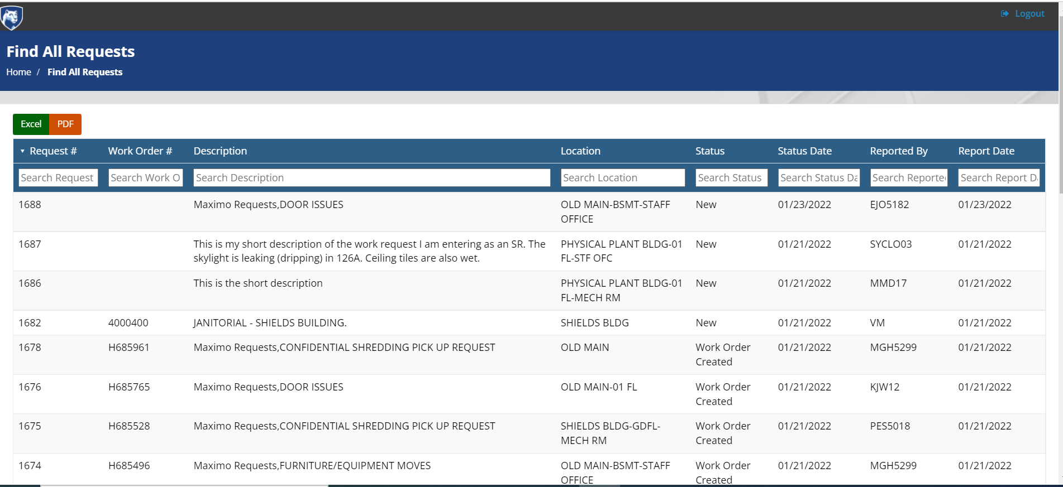

*VIEW All – VIEW SERVICE REQUEST AND ASSOCIATED WORK ORDER DETAILS*

When selecting a Service Request from either the Find or View Tiles, users will see the Service Request details, including SR logs and any work orders generated from the SR. To view the work order details, select the specific work order.

SR Details shown below.

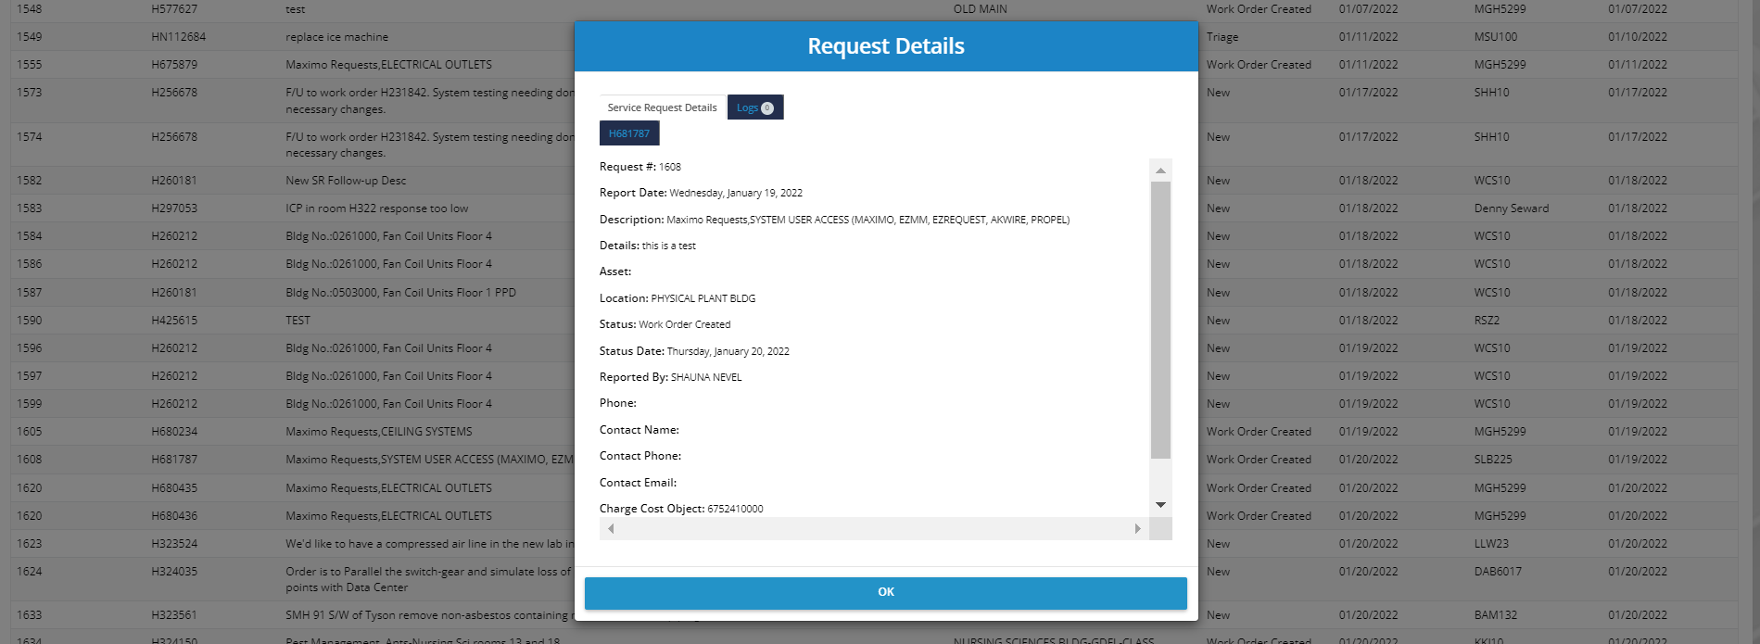

Work Order Details

After selecting a request from the Find or View tiles, a user can see associated work order details by clicking on the work order listed under the Service Request details. This will then open the work order tabs in the details.

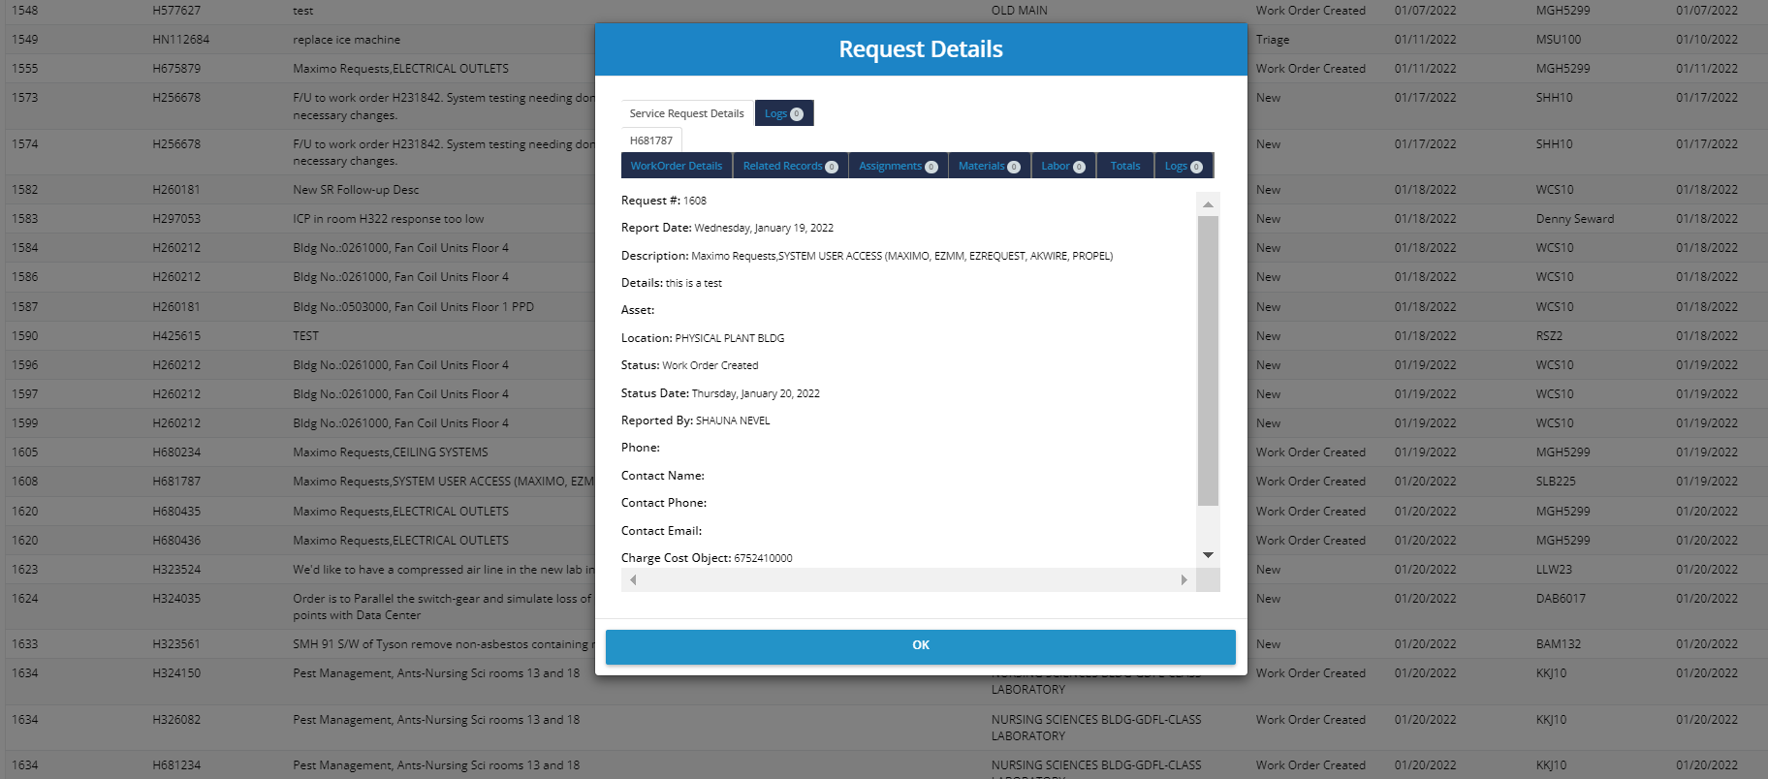

## 

## CREATE A NEW WORK REQUEST

Users can create a new service request by selecting the **Create** tile. After selecting Create, users are brought to the New Work Request screen.

1. Enter Contact Information.

* The contact information for the user signed in to EZRequest will display at the top of the work request. If there is another point of contact for the service request, other than the requestor, users should enter their name, phone number and email address.

1. Select the Location of the Work.
2. Select the Category of Work.
3. Enter Charge Cost Object (CCO), i.e. the budget paying for the work/service and which the requestor is authorized to use.
4. Enter a Description of the Work or Service needed.
5. Optional: Add attachments.
6. Submit Request

See the next sections providing more details about each step of creating an EZRequest Service Request.

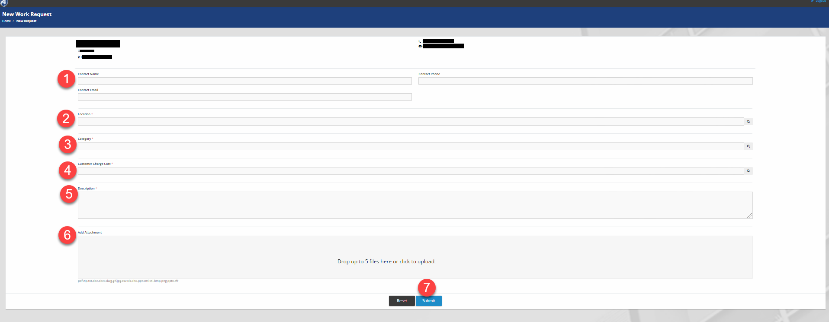

### 

### New Work Request – Searching/Selecting a Location

Users can search based on the location/building number or the building name/description. The search box is sorted on the location number from ascending to descending (i.e. lowest building number to highest). The building numbers and names are integrated from LionSpaceFIS.

1. The bottom of the dialogue box shows the number of location records being displayed out of the total number of locations available.
2. Users can also navigate to a specific page,
3. Select search results or,
4. Cancel or clear the search.

As soon as a user starts typing in the search bar, results filter immediately.

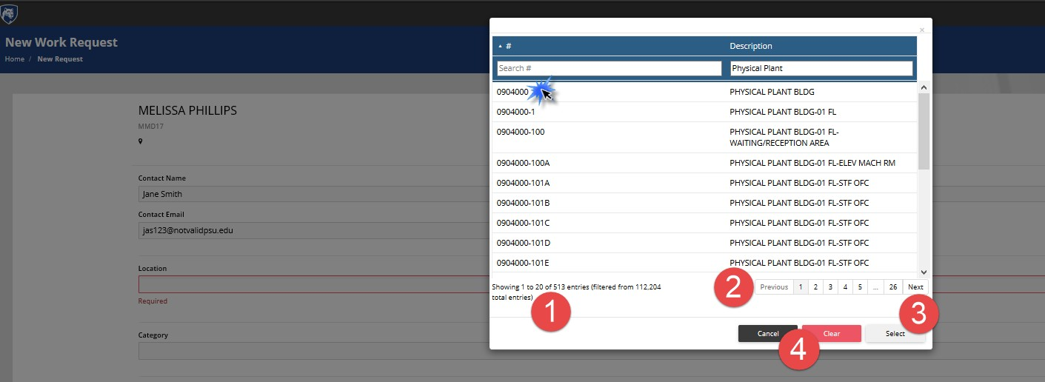

### New Work Request – Searching/Selecting a Category

Users can search for a specific category of requests. Note: Users should only see the categories applicable to their campus. Commonwealth campuses may have additional categories to which requestors at the University Park site do not have access.

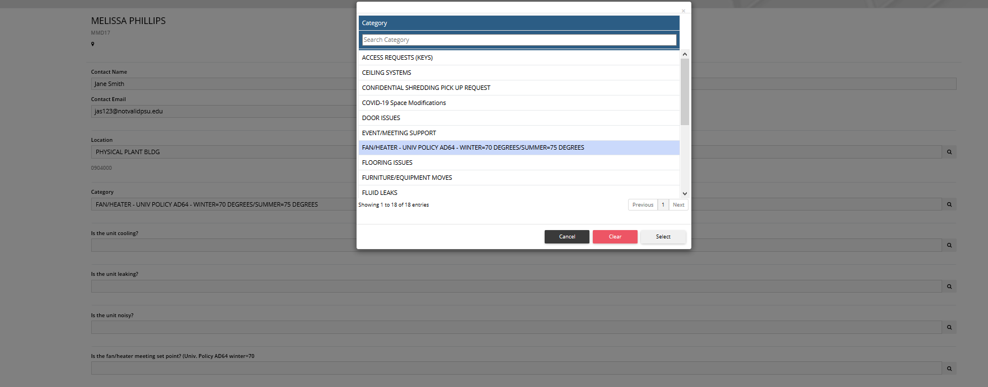

Once a category is selected, the form will update with appropriate questions regarding that category of work.

Note: If a user selects a category, fills out the questions and then changed the category, the data entered for the original questions will be lost.

### New Service Request – Financial Information

Pre-SIMBA, selecting a location of the work request caused the Customer Billing Number (CBN) to populate. Since SIMBA’s implementation, CBN has been retired and replaced by Charge Cost Object (CCO). The CCO represents the budget being billed for the work. While the CCO field is not enforced or validated on the submission of the Service Request from EZRequest, the CCO will need to be populated. The financial data is validated against the SIMBA Spending Authorization Table during triage of the work order and must pass validation before a work order will be approved. The EZRequest user/requestor will be assumed as the financial sponsor and will need financial authority to request customer funded service or work on the provided CCO.

REMINDER: Spending Authority is a SIMBA requirement and separate from the granting of EZRequest permissions.

Charge Cost Object (CCO) – In Maximo, there is only one segment of the chart of accounts – the cost object. The cost object could be a cost center, internal order, or Work Breakdown Structure (WBS) Element, but all are referred to as a cost object in Maximo. The Charge Cost Object represents the budget paying for the work.

Financial Sponsor (FS) is the person requesting the work and who has financial/or spending authority to request work on the specific charge cost object, i.e., are listed on the SIMBA Spending Authority table as authorized to spend on the specific Charge Cost Object.

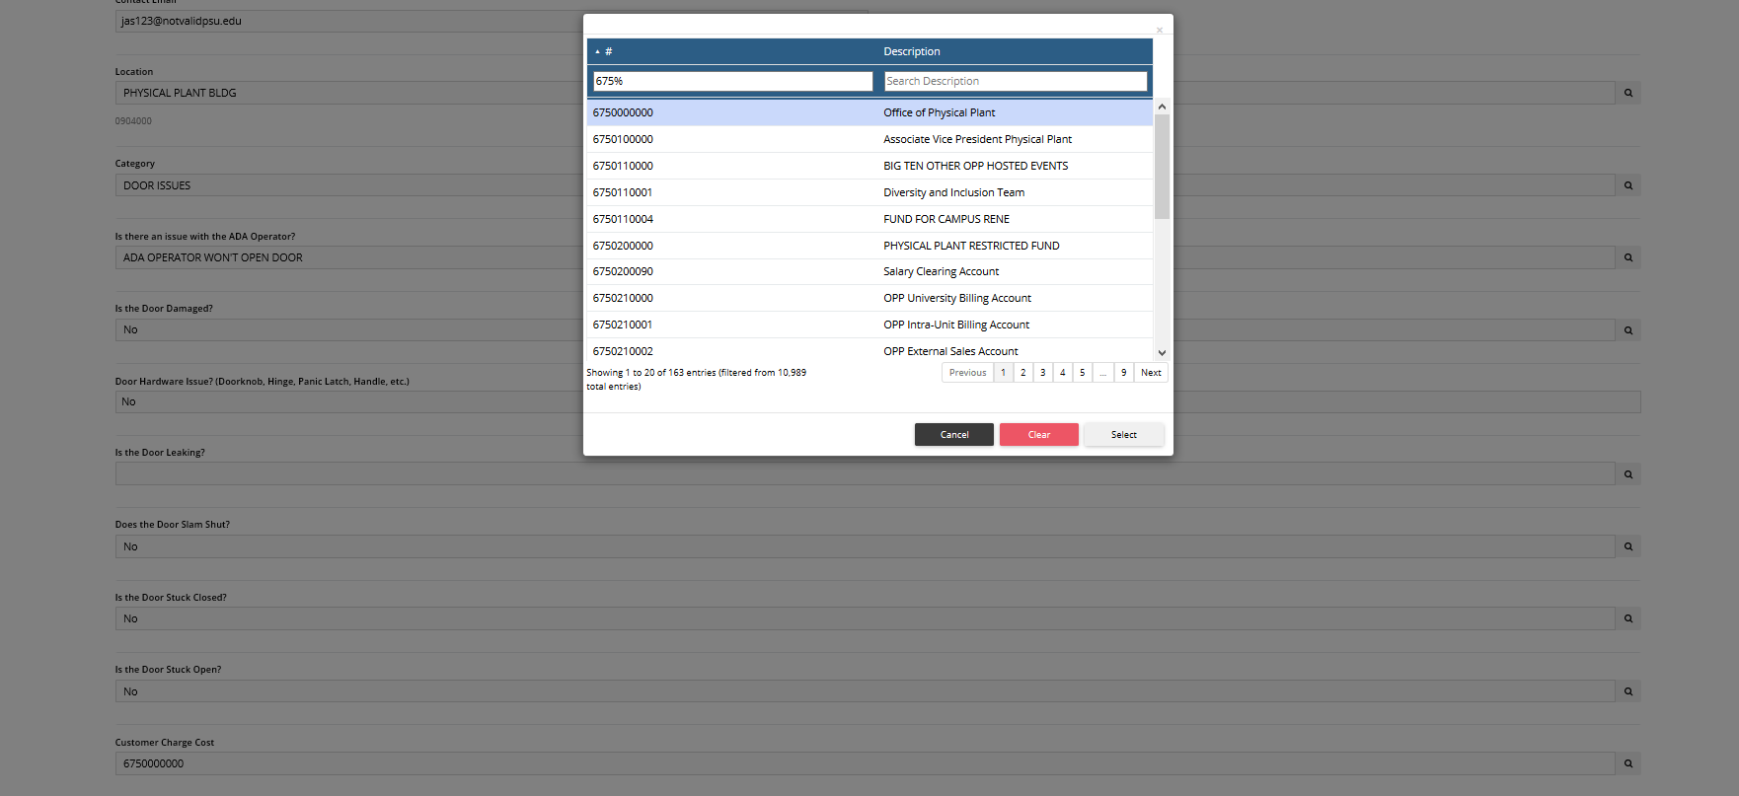

### New Service Request – Description

Enter a detailed description regarding the issue or work being requested. Users should enter sufficient details to provide the necessary context and details so the Facilities Specialist triaging the request and the technician receiving the work order has sufficient information to understand the problem/request and execute the work.

When entering a request, remember that stating all details (even details that may seem obvious) should be included in the description of the request.

For Event Requests, be sure to provide sufficient details regarding the event logistics, the requested set-up, and event specific needs. For example, when requesting tables and chairs, it is important to not only specify the number needed, but also provide a map of how you would like the space configured.

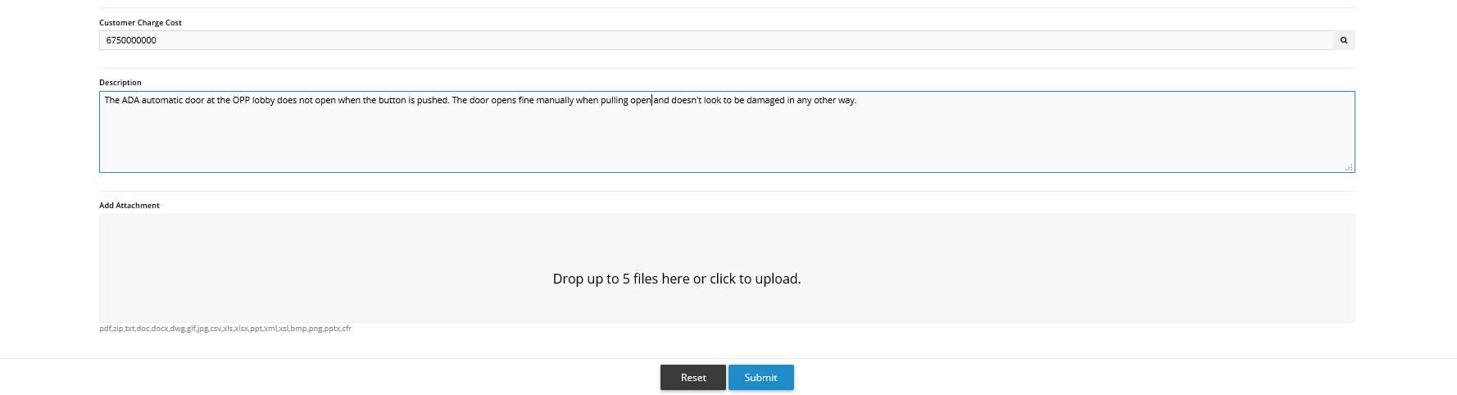

### New Service Request – Add Attachments

Users can drag and drop or browse their computer files and upload up to 5 files to attach to a service request (which will attach to a work order if a work order is generated from the SR).

The following file types are accepted: pdf, zip, txt, doc, docx, dwg, gif, jpg, csv, xls, xlsx, ppt, xml, xsl, bmp, png, pptx, cfr

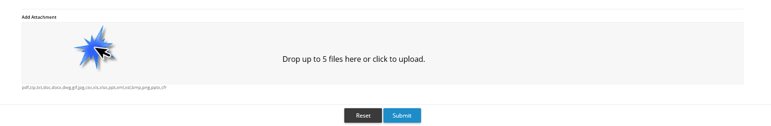

### New Service Request – Submission Receipt Confirmation

Users will receive a submission receipt after successfully submitting their Service Request. It provides the Service Request number and a link to check the status of the SR in the Find My Request tile.

