

EZREQUEST USER GUIDE

Commonwealth Campus Edition Including SIMBA Implementation Changes



# Document Control

|  |  |
| --- | --- |
| **Title** | EZRequest User Guide – Commonwealth Campus Edition |
| **Author** | Melissa Phillips |

|  |  |  |  |  |
| --- | --- | --- | --- | --- |
| **Owner (Responsible for Approval of Issued Versions)** | | | | |
| **Name** | **Role** | **Signature** | **Date** | **Issue** |
| Melissa Phillips | Education Program Associate 2 | Melissa Phillips | 2/1/2022 | 1 |

|  |  |
| --- | --- |
| **Change Log** | |
| **Date** | **Change** |
| 6/7/2022 | Pages updated to specify that record in a Canceled or Closed Status are excluded from search results. |
|  |  |
|  |  |

Table of Contents

Document Control 1

What’s New? 3

Benefits of EZRequest? 3

WHO CAN USE EZREQUEST? 3

NAVIGATING TO LOGIN SCREEN 5

Finding and Signing into the application (app) 5

WELCOME SCREEN 7

FIND 8

VIEW ALL 9

CREATE A NEW WORK REQUEST 12

New Work Request – Searching/Selecting a Location 13

New Work Request – Searching/Selecting a Category 14

New Work Request – Financial Information 15

New Work Request – Work Request Description 16

New Work Request – Add Attachments 16

New Work Request – Submission Receipt Confirmation 17

EZREQUEST

### What’s New?

EZRequest replaced SuiteReq in March 2020. EZRequest is a simplified, modern webform which allows authorized Penn State employees the ability to submit and track work requests without requiring the use of a Maximo license. The solution was developed in collaboration with OPP’s Enterprise Asset Management team and InterPro Solutions Inc.

### Benefits of EZRequest?

* Instant Search, i.e., users are provided instant search results as they type.
* Modern looking, easy-to-use webform
* Users won’t consume a Maximo license providing a cost savings to the University by not consuming unnecessary Maximo licenses

## WHO CAN USE EZREQUEST?

Authorized Penn State employees identified and approved by their Facility Coordinator (FC) to submit Work Requests to OPP. Designated OPP employees may utilize EZRequest for initiating work requests.

Newly hired Penn State employees (outside of OPP-UP) requiring access to EZRequest should have a supervisor or representative submit a service request for access or email OPP’s EAM team at [oppmaximo@psu.edu](mailto:oppmaximo@psu.edu) to request EZRequest access.

With the implementation of SIMBA in July 2020, EZRequest users will also need to have financial authority for the cost objects they are requesting work/or services on that are not maintenance related. A customer funded request will need to be entered by someone who is listed on the SIMBA Spend Authorization Table for the budgets which they are authorized to incur expenses on. Users would need to work with their Facility Coordinator or Supervisor and Financial Officer to obtain financial authority on the SIMBA Spend Authorization Table. Financial Authority is a SIMBA requirement and separate from EZRequest Access/Permissions.

Unauthorized users attempting to log in to EZRequest will receive the following error:

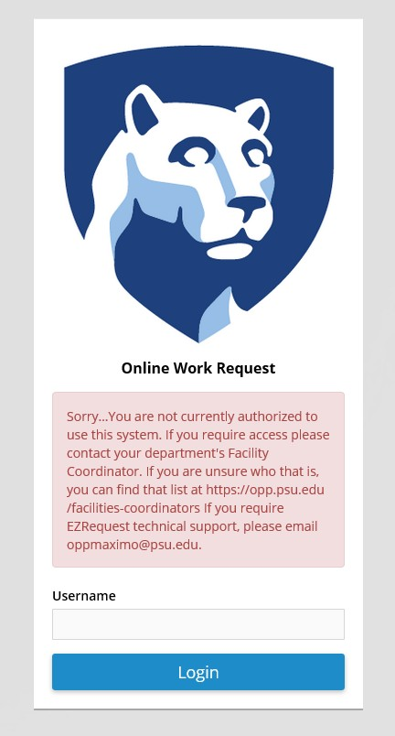

## NAVIGATING TO LOGIN SCREEN:

### Finding and Signing into the application (app)

A link to [EZRequest](https://ezrequest.opp.psu.edu/ezrequest) can be found on the OPP Website, opp.psu.edu, under OPP Quick Links. EZRequest URL: <https://ezrequest.opp.psu.edu/ezrequest>

EZRequest will require login with your Penn State User credentials.

## WELCOME SCREEN

On the Welcome screen, users can:

* View and search through their own previously submitted work requests in any status,
* View work orders (except PMs) that are not in a Canceled or Closed Status,
* Create a new work request.

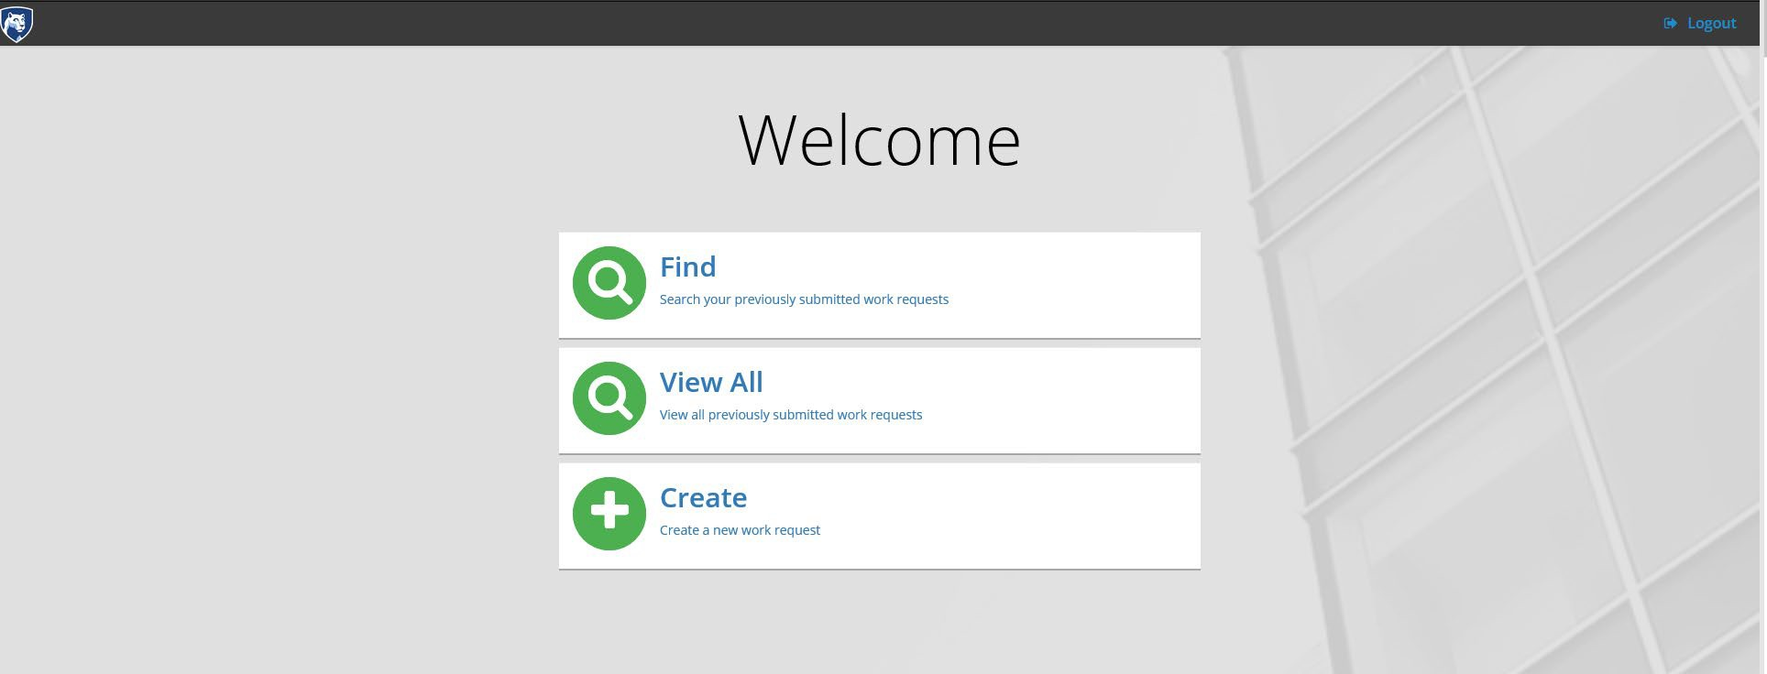

## FIND

The Find tile allows users to view and search all of their own previously submitted work requests. Review the navigational features of tiles below.

1. To return the Welcome screen, click on “Home.”
2. To export a list of work requests to Excel or PDF, click on the respective file type button. Note: The results you are displaying are the results you will export. In the example below, the entire result set is being displayed.
3. On the filter bar, you can instantly search and sort results by Work Order #, Work Order Description, Location Description, Work Order Status, Last Status Date and Reported Date.
4. Users can navigate through different pages of records by selecting the page number, previous or next options.
5. To logout of the system, Select “Logout” in the top right of the screen.

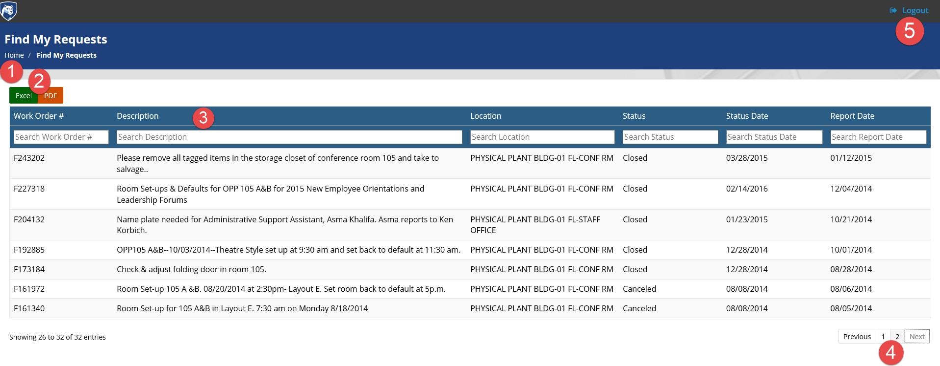

## VIEW ALL

By selecting the View All tile, users can search and view open work orders, with the exception of Preventive Maintenance (PM) work orders and work orders in a Canceled or Closed Status. PMs were excluded in a conscious effort to improve search speed. The **View All** tile is different from the **Find** tile in that viewers can search more than just their own previous requests.

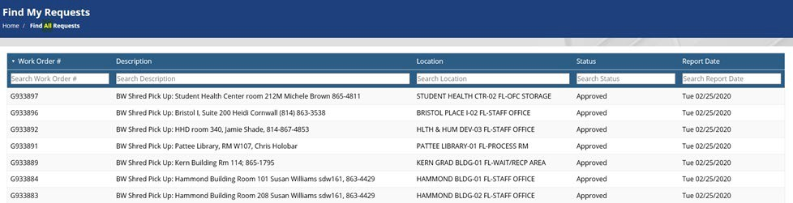

*VIEW All – VIEW WORK ORDER DETAILS*

When selecting a work order from either the Find or View Tiles, users can see details about the work order, including the new SIMBA related financial fields Charge Cost Object and Financial Sponsor.

Charge Cost Object (CCO) – In Maximo, there is only one segment of the chart of accounts – the cost object. The cost object could be a cost center, internal order, or Work Breakdown Structure (WBS) Element, but all are referred to as a cost object in Maximo. The Charge Cost Object represents the budget paying for the work.

Financial Sponsor (FS) is the person requesting the work and who has financial/or spending authority to request work on the specific charge cost object, i.e., are listed on the SIMBA Spending Authority table as authorized to spend on the specific Charge Cost Object.

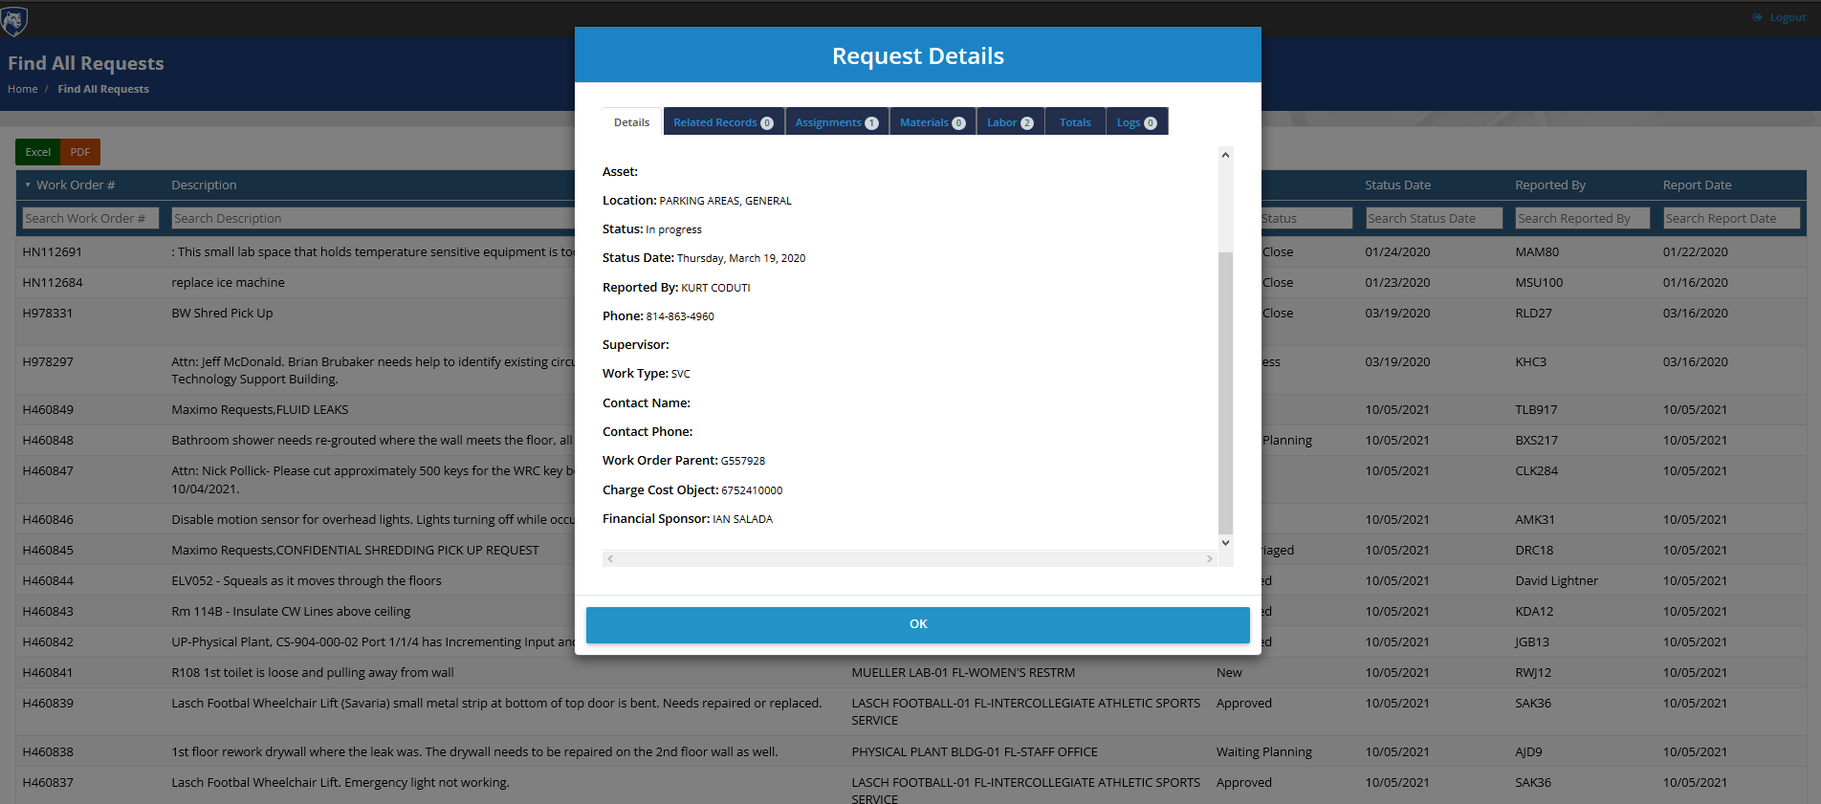

Work Order Details with SIMBA-Integrated EZRequest/Maximo

With the implementation of SIMBA, the new Chart of Accounts structure has precipitated the need for different financial fields in Maximo, i.e., Maintenance Cost Object, Charge Cost Object and Financial Sponsor. The Maintenance Cost Object (MCO) is the budget responsible for maintenance. Pre-SIMBA, the MCO was called the GL Account. The Charge Cost Object (CCO) is the budget paying for the work. The Financial Sponsor is the person requesting the work and who has financial/or spending authority to request work on the specific charge cost object.

## 

## CREATE A NEW WORK REQUEST

Commonwealth Campus EZRequest Users can create a new work order request by selecting the **Create** tile. After selecting Create, users are brought to the New Work Request screen.

1. Enter Contact Information.

The contact information for the user signed in to EZRequest will display at the top of the work request. If there is another point of contact for the work request, other than the requestor, users should enter their name, phone number and email address.

1. Select the Location of the Work.
2. Select the Category of Work.
3. Enter Charge Cost Object (CCO), i.e. the budget paying for the work/service and which the requestor is authorized to use.
4. Enter a Description of the Work.
5. Optional: Add attachments.
6. Submit Request

See the next sections providing more details about each step of creating an EZRequest Work Request.

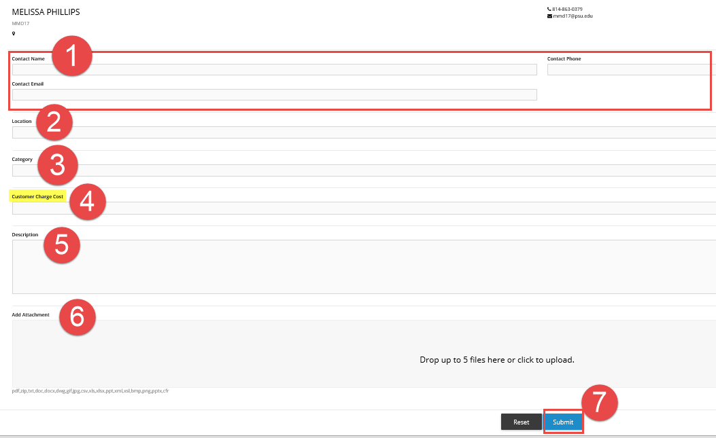

### New Work Request – Searching/Selecting a Location

Users can search based on the location/building number or the building name/description. The search box is sorted on the location number from ascending to descending (i.e. lowest building number to highest). The building numbers and names are integrated from LionSpaceFIS.

Note: In Pre-SIMBA EZRequest, a customer billing number previously auto populated after a location was selected and users updated the CBN as appropriate. With SIMBA’s implementation, the use of Customer Billing Numbers has ceased for billing purposes. Thus, the CBN field has been removed from the page and has been replaced with Charge Cost Object (CCO) field.

1. The bottom of the dialogue box shows the number of location records being displayed out of the total number of locations available.
2. Users can also navigate to a specific page,
3. Select search results or,
4. Cancel or clear the search.

As soon as a user starts typing in the search bar, results filter immediately.

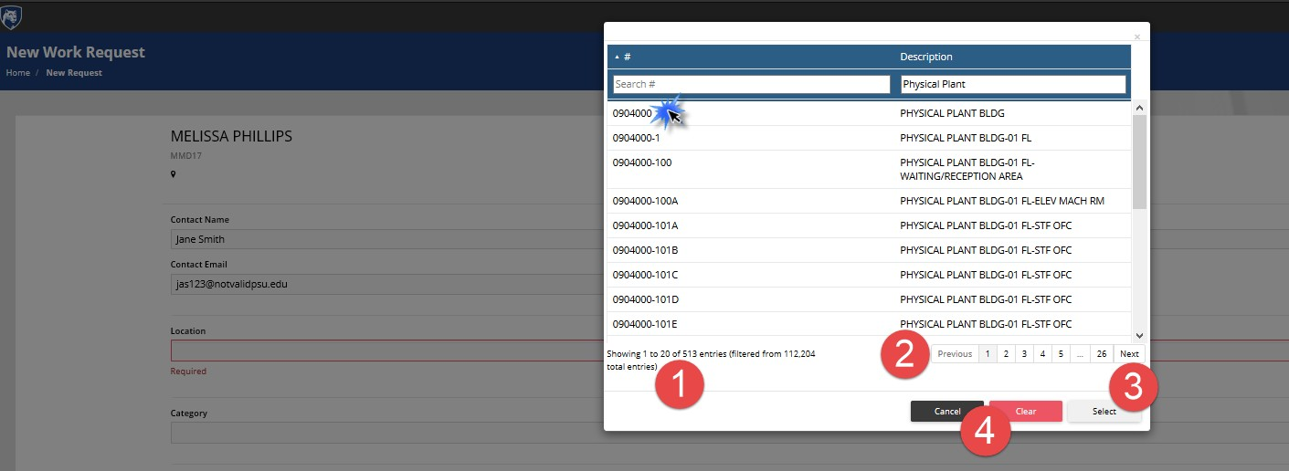

### New Work Request – Searching/Selecting a Category

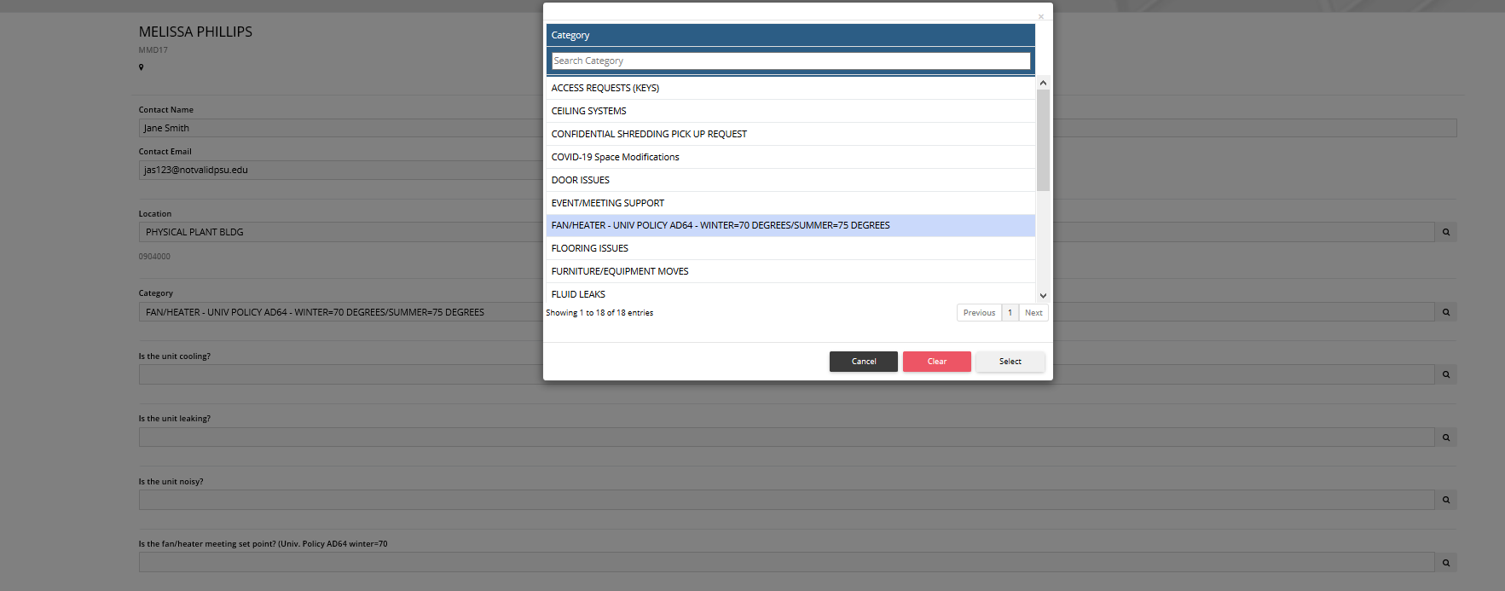

Users can search for a specific category of work requests. Note: Users should only see the categories applicable to their campus. Commonwealth campuses may have additional categories which requestors at the University Park site do not have access.

Once a category is selected, the form will update with appropriate questions regarding that category of work.

Note: If a user selects a category, fills out the questions and then changed the category, the data entered for the original questions will be lost.

### New Work Request – Financial Information

In EZRequest Pre-SIMBA, selecting a location on the work request caused the Customer Billing Number to auto-populate. With the implementation of SIMBA, CBN is being retired and being replaced by Charge Cost Object (CCO). The CCO represents the budget being billed for the work. While the CCO field is not enforced or validated on the submission of the EZRequest work order, the CCO will need to be populated. The CCO and the financial sponsor (requestor) will be validated against the SIMBA Spending Authorization Table during triage, before approval of the work request. The EZRequest user/requestor of the work order will be assumed as the financial sponsor and will need financial authority to request customer funded work.

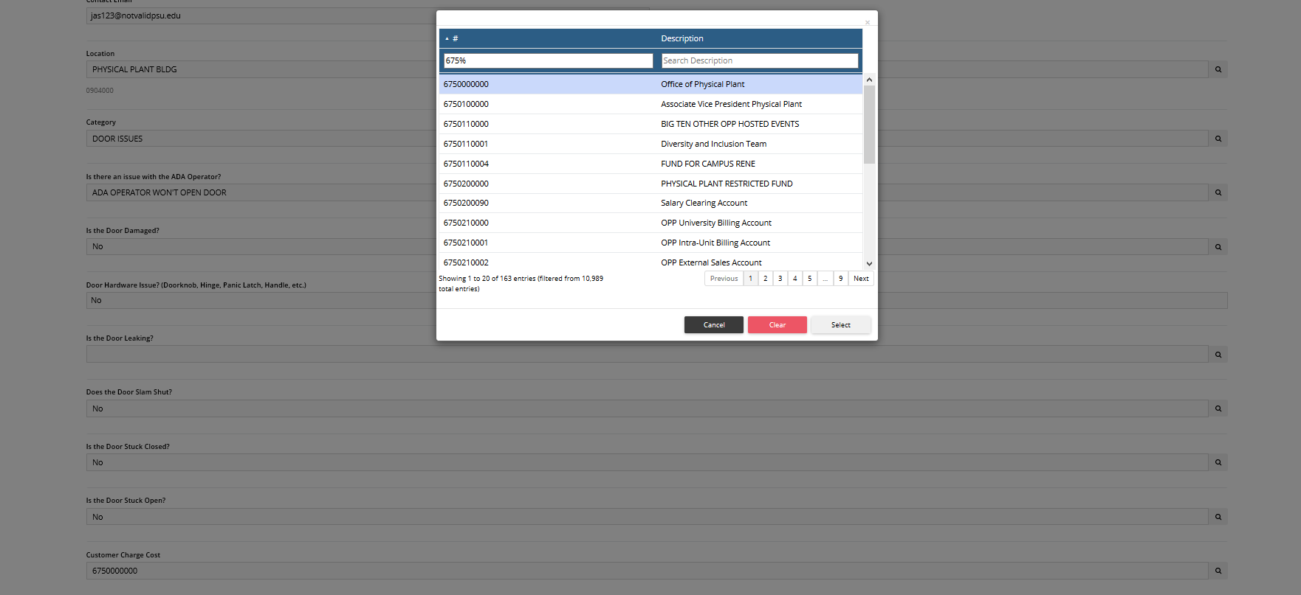

### New Work Request – Work Request Description

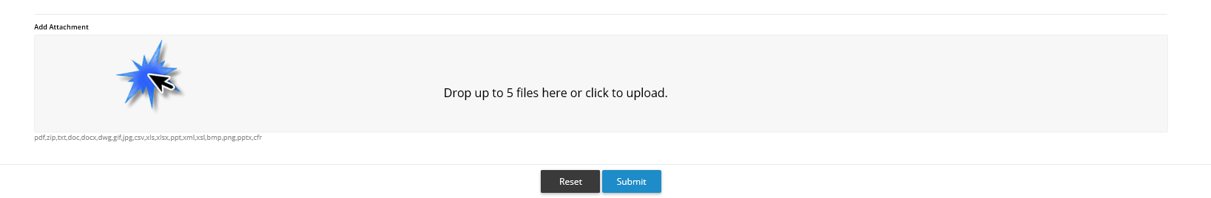

Enter a detailed description regarding the issue or work request being submitted. Users should enter sufficient details to provide the necessary context and details so a technician receiving the work order understands the problem/request.

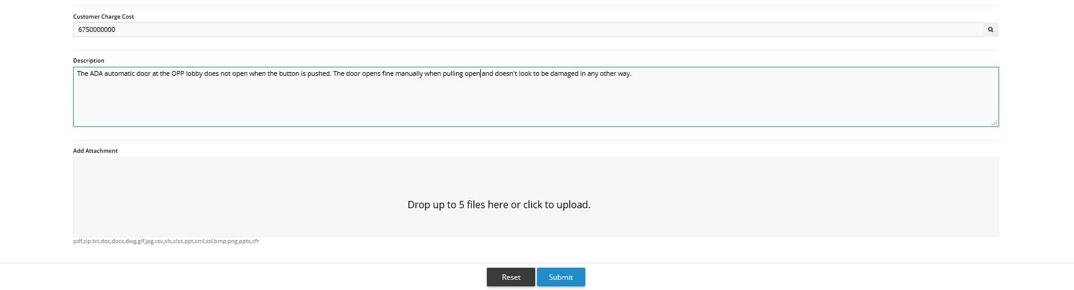

### New Work Request – Add Attachments

Users can drag and drop or browse their computer files and upload up to 5 files to attach to a work request. The following file types are accepted: pdf,zip,txt,doc,docx,dwg,gif,jpg,csv,xls,xlsx,ppt,xml,xsl,bmp,png,pptx,cfr

### New Work Request – Submission Receipt Confirmation

Users will receive a submission receipt after successfully submitting their work request. It provides the work order number and a link to check the status of the request in the Find My Request tile.

