Penn State Enterprise Asset Management Strategy

The Office of Physical Plant (OPP) Enterprise Asset Management strategy defines the management approach for designing, constructing and maintaining physical assets that are critical and important for meeting Penn State’s mission and business objectives. These business objectives include many facets of activity at Penn State that required a management organization that is well informed and employs an integrated information system that is structured to meet current and future goals in support Penn State’s Sustainability Program, high levels of asset performance, minimize risk and control costs. The integrated information system must be accurate, reliable and easily used for the management of assets and related asset life cycle activities.

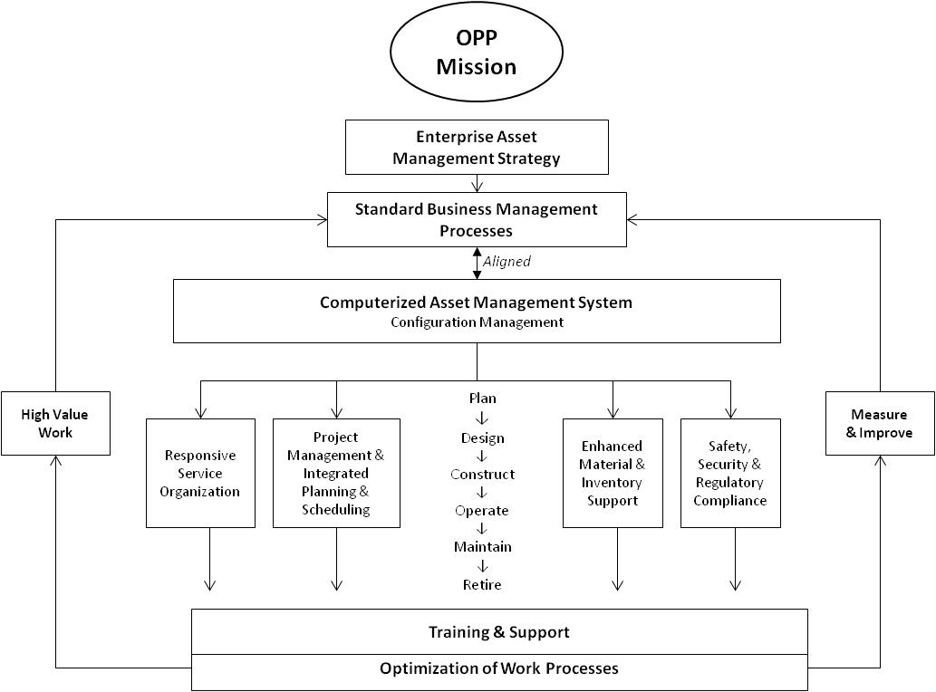

The following statements provide the foundation for developing standards and management information systems to meet these OPP business objectives:

- Standardized Business Processes – Asset management includes a risk-control process whereby decisions are made regarding the use of resources to lower the risk of asset impairment or failure. With a full understanding of the importance of the asset in the support of the organization’s goals; resources can be allocated to meet Sustainability Program requirements, for all types and phases of planning, design, construction and operation & maintenance programs. Standard business processes across Penn State facilities directly support multiple features of asset life cycle activity including planning, allocation of budgetary and manpower resources; prioritization of work and replacement/refurbishment of assets, and development of performance and process metrics to ascertain best practices and monitor asset vulnerabilities across Penn State University assets
- Deploy a Computerized Asset Management System – To the extent that the benefits outweigh the financial and indirect costs, OPP will use and integrated asset management system and database that supports full asset life cycle activity. The management of assets will include such activities as planning, facility design, construction, engineering & operations and maintenance management. The database will include sustainability program activity, work performed, work history, cost tracking, planning and scheduling of manpower and material resources, asset prioritization, condition monitoring, and related information to support management’s business objectives.
- Apply Asset Management Database Configuration - the management of the asset data base including the data configuration, change control and access control are to be maintained in a formal information technology configuration management program. The asset management system must be available on a full-time basis and be backed up. Configuration management must include a disaster recovery program. All changes to the configuration must be documented and formally approved by management before being released for production.
- Provide a Highly Responsive Service Organization- OPP responds to a large population of students, faculty, staff and visitors that can identify problems across the campus with facilities, housing, equipment, assets and other issues that may impact the individual’s needs. Provisions must include all services that support the mission such as space planning, master planning, design services, project coordination and other services important to meeting basic obligations of OPP. The asset management database provides the information required for dispatching, tracking and reporting work performed in response to request for service and support provided by OPP.
- Establish a Project Management Program – the planning, design and construction phase of asset life cycle is the starting point for creating new assets in to the asset database. Specific management guidelines provide for the timing and process of setting up and applying the asset management database to collect and enter information for critical and important assets. The asset database design and configuration will support the management and tracking of assets during the design and construction phase. A formal process of transferring the construction asset data status to the operations and maintenance organization is required. Since the Sustainability Program requirements begin in this asset life cycle phase; the asset database must support the attributes for asset sustainability design and construction that enable tracking Sustainability Program accomplishments
- Enhance Material and Inventory Support – Through the use of the asset database information, and collaboration with maintenance planners and construction project planning, the management of inventory will ensure critical parts/spares are available when they are required to support accomplishing scheduled maintenance and project work. Inventory of critical parts/spares is optimized through standardization of part numbers, clear part descriptions, and available quantities in stock. Frequent communication among maintenance, inventory, and purchasing professionals will use common information systems to support the planned and scheduled work.
- Support Safety, Security and Regulatory Compliance– the asset database will be the official source of information used to support assets that are required to meet safety, security and other asset related requirements to meet Federal, State and local regulatory reporting and information requirements.
- Provide Training Support – the application and use of the asset management database is complex, as are the business processes to support the organization’s need to meet their business objectives. As the organization requires a high-end, integrated asset management database to support these activities; it also must invest in the appropriate, long-term training and support to use database system. The standardization of business practices, data, inventory, and configuration allows the organization to develop and continually deliver standardized, appropriate training for management and staff.
- Optimization of Work Processes – Efficiency is the application of available resources to achieve a particular outcome at the least cost. Efficiency is enhanced when the information in the asset management database is used to schedule labor, material, and equipment resources for accomplishing work. The coordination of activities and work to optimize time associated with resources results in an efficient and cost effective performance of the work force. The integration of planned and scheduled work groups within the organization enables management and supervision to fully utilize resources. Planning effort defines technical work content, materials tools and labor requirements to accomplish work effectively. Scheduling objectives are the allocation and timing of resources to optimize performance and support integration between work groups within the specified time period.
- Strengthen the use of information to enhance the integration of key programs – OPP has a large number of programs that will benefit from sharing a common asset database. These programs cross organizational boundaries and the sharing of a common set of asset information is critical to improving the decision making processes. Programs such as continuous commissioning, space planning, space utilization, engineering assessments and many other programs must have the opportunity to share common information that is readily available in a controlled and protected database.
- Accomplish High-Value Work – the organization employs an asset and work order priority system to ensure resources are focused on accomplishing the highest-value work first. High-value work directly supports the care of critical and important assets that enables the OPP to achieve its principal goals of sustainability, meeting staff, student and visitor requirements, cost effectiveness, safety and security. The asset database is the primary source of information to assist in the tracking and scheduling of work so that the highest-value work is readily identified and can be scheduled on a priority and resource availability basis.
- Deploy a Metrics and a Performance Reporting Program – Standardization of business practices, critical data, and uniform database configuration enables the use of an organizational-wide reporting system of performance metrics and indicators. Metrics must facilitate identifying potential best practices for asset life cycles activities including design, construction and maintenance. Support activities such as material support, contract management, budget and cost tracking, sustainability requirements and other major programs may be included in the metrics program. Metrics are designed to reflect management and supervision’s performance as related to their role for the successful performance asset life cycle activities.

